

North East Migration Partnership Newsletter December 2025
The NEMP (North East Migration Partnership) Newsletter brings together various sources of information, which relate to Refugees, Asylum Seekers, and Migration in the region. If you have any suggestions for additional content, please email: nemp@middlesbrough.gov.uk. We hope you enjoy reading it, any feedback you have will be welcomed so we know if we are hitting the right spot or not.
CONTENTSs
Asylum Updates 1
Asylum – Home Office Statistics 2
Hong Kong BN(O) Welcome Programme 3
Unaccompanied Asylum Seeking Children (UASC) 4
Ukraine Schemes 5
Refugee Resettlement 5
ESOL & Employability 8
NEMP Website 10
Health 10
Modern Slavery 11
No Recourse to Public Funds (NRPF) 12
Migrant Help Update 13
Funding Opportunities 13
News and reports 13

Asylum Updates
Home Office Asylum and Returns Policy Statement
On 17 November 2025, the government published “Restoring Order and Control – a statement on the government’s asylum and returns policy”. Access the statement here.

Severe Weather Emergency Protocol (SWEP)
The Home Office has confirmed that when a local authority activates its Severe Weather Emergency Protocol (SWEP), it should contact both the Home Office and Mears. In these cases, up to three additional nights of asylum support accommodation will be provided for anyone facing imminent eviction.

Under SWEP, local authorities ensure that everyone—regardless of status—has access to a bed, preventing anyone from being exposed to serious harm by sleeping outdoors in freezing conditions. For details on local arrangements and procedures, please reach out to your local authority.

Home Office Festive Easement of Discontinuations
The Home Office has updated that Friday 19th December 2025 will be the last date evictions for this year, evictions will resume Monday 5th January 2026. This allows for the additional Bank Holiday in Scotland on Friday 2nd January.
- Last date for evictions on discontinuations – Friday 19th December 2025.
- First day for evictions to recommence – Monday 5th January 2026.

Home Affairs Committee – The Home Office’s management of asylum accommodation
The Home Affairs Committee has published its findings and recommendation for ‘The Home Office’s management of asylum accommodation’. You can access the report here.

CIH Housing Rights Guide
This short guide from the CIH Housing Rights website is designed for professionals supporting asylum seekers in hotels or other asylum accommodation. It primarily covers options available to those granted asylum. Individuals who are refused asylum may need to focus on appeal rights or consider moving to Section 4 support if they cannot leave the UK. For detailed information on these areas, see the briefings provided by the Asylum Support Appeals Project.

Analysis of the Asylum system – National Audit Office (NAO)
The NAO has mapped out the asylum system end-to-end to show the causes of delay and inefficiency - the first time it has been presented in this way. The public spending watchdog has also created an interactive data visualisation and analysed a sample of 5,000 asylum cases lodged almost three years ago, finding over half (56%) of those people still do not have a final outcome. Following the Home Secretary’s newly announced measures to overhaul the asylum system – many of which will take time and Parliamentary approval to introduce – the NAO has set out four requirements needed for an effective, value for money system. The report and further information can be found here.

Asylum – Home Office Statistics
To access the raw publicly available information, click here. This information can also now be viewed on our data page on the NEMP website, here where we have provided some analysis for stakeholders to use to support briefings and funding bids.

North East Dispersal Accommodation Data
As of the end of Q3 2025, the North East housed 6,829 asylum seekers who were in receipt of support in Dispersal Accommodation. Below is a breakdown with a comparison of Q3 2024 to Q3 2025.
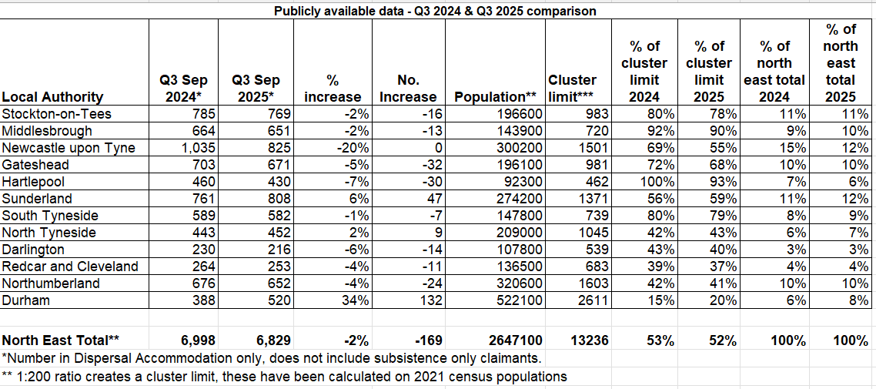

North East Contingency Accommodation Data
As of the end of Q3 2025, the North East housed 369 asylum seekers who were in receipt of support in Contingency Accommodation. Please see below for a regional overview.
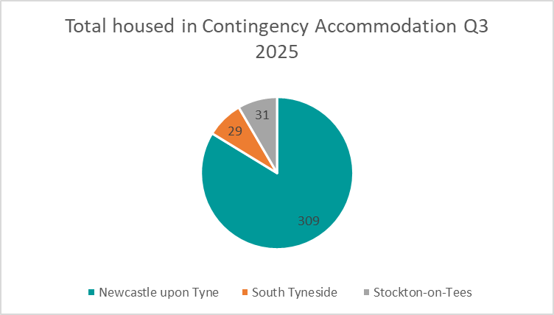

National Dispersal, Initial and Contingency Accommodation Data
As of the end of Q3 2025, the North East housed 7% of the national total of asylum seekers who were in reciept of support in Dispersal, Initial and Contingency Accommodation. Below is a national breakdown.
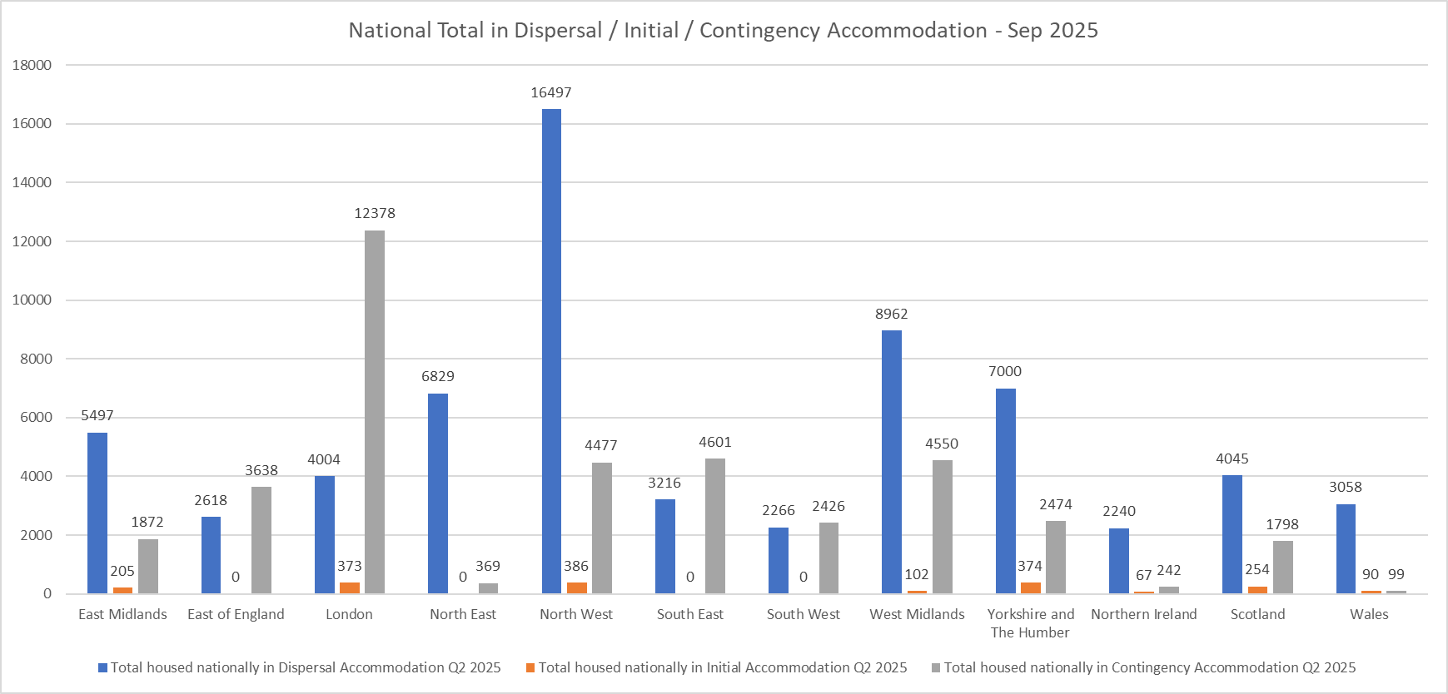

Hong Kong BN(O) Welcome Programme
North East Hongkongers Club
The North East Hongkongers Club continues to welcome new arrivals into the region, providing a range of activities in-person and online, and upcoming events can be found here.

The Comfrey Project
NEMP has funded The Comfrey Project to deliver a number of projects until March 2026, such as a women’s only drop-in, a cooking class, and ‘Grow Your Skills’ sessions. These projects are open to anyone in the NE region, on the Ukraine, Hong Kong BN(O) or Afghan scheme. For further information on upcoming events and activities, please visit The Comfrey Project on Facebook.

The Comfrey Project is also delivering an English for Employability and Volunteering course – which is a 4-week program delivered by an experienced ESOL teacher. It will be taking place Mondays 12-3pm, from 5 January to 26 January 2026. Details on how to register can be found in the poster below.
Immigration White Paper
Hong Kong BN(O) visa holders express significant concerns over proposed changes in the UK's Immigration White Paper, including an increased 10-year path to Indefinite Leave to Remain (ILR) instead of the current five years, new English language requirements, and the potential for retrospective application of these new rules.

On 20 November 2025, the Home Office published a consultation paper, A Fairer Pathway to Settlement outlining proposals to reform the UK’s immigration settlement rules. The proposals aim to replace automatic settlement after a fixed period with an “earned settlement” model, where permanent residence is earned through meaningful contribution to UK society and the economy. Within the document, it outlines that Hong Kong BN(O)s will retain their 5-year pathway to settlement, subject to meeting the mandatory requirements on page 21. A consultation is open for 12 weeks until 12 February 2026, which encourages anyone wishing to share their views, including people, organisations, and other stakeholders affected by or interested in the proposed changes, to do so via the online form. Further information can be found in the statement here.

Immigration Statistics
The Home Office has released the Immigration Statistics as of September 2025. There has been a total number of 184,203 grants on the Hong Kong BN(O) scheme since the scheme opened on 31 January 2021. Nearly 1,500 individuals on the BN(O) route have been granted settlement. The BN(O) route came into effect in January 2021 and typically requires 5 years of continuous residence in the UK before becoming eligible for settlement. Some individuals may be qualifying earlier, where time spent on other eligible visa routes, prior to moving onto the BN(O) route, counts towards their 5-year residence period. Further information can be found here.

Unaccompanied Asylum Seeking Children (UASC)
Department for Education children looked after data
The Department for Education has recently released the yearly figures for children looked after (CLA) across England, the data has been collected between 31 March 2024 to 31 March 2025 and provides a national picture for the number of UAS children who are currently looked after by local authorities across the country.

As illustrated below, the number of UAS children looked after peaked in 2024 with 7,440 children in local authority care and has fallen by 12% in 2025 with 6,540 UAS children in care. In 2025, UAS children represent 8% of the total number of children looked after in England with the majority of these young people living in Ofsted-registered supported accommodation properties and 38% in foster placements.
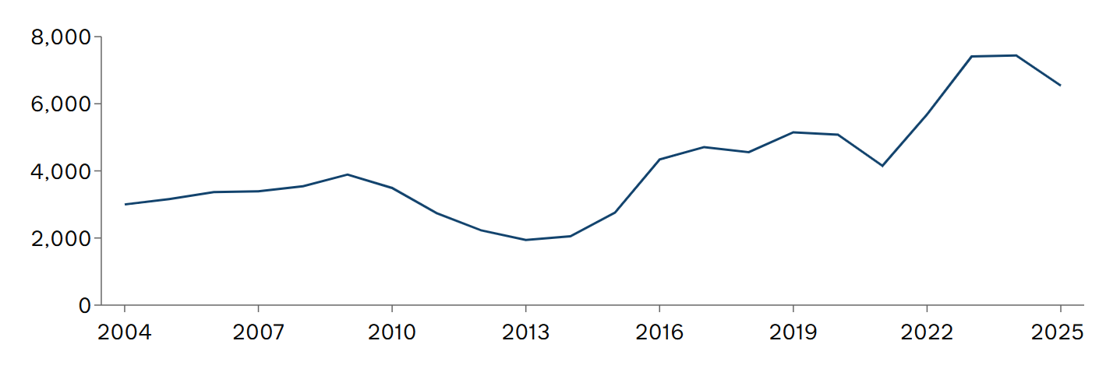

NTS Publicly Available Data
The table below compares the number of unaccompanied asylum seeking children who transferred into North East local authorities in Q3 over the past four years. The North East transferred 46 children in total between July-September, lower than the previous two years. So far in 2025, North East local authorities have welcomed 121 children via the NTS.

Nationally, 883 children transferred during Q3 with North East local authorities receiving 5% of NTS transfers.

Transfers completed under the National Transfer Scheme, Q3 2022-2025
 | 2022 Q3 | 2023 Q3 | 2024 Q3 | 2025 Q3
County Durham | 6 | 28 | 11 | 8
Darlington | 5 | 4 | 4 | 0
Gateshead | 8 | 9 | 2 | 2
Hartlepool | 1 | 2 | 2 | 2
Middlesbrough | 3 | 4 | 3 | 5
Newcastle upon Tyne | 2 | 1 | 3 | 3
North Tyneside | 5 | 9 | 4 | 4
Northumberland | 0 | 4 | 4 | 7
Redcar & Cleveland | 0 | 4 | 7 | 5
South Tyneside | 3 | 3 | 4 | 5
Stockton on Tees | 5 | 10 | 4 | 2
Sunderland | 3 | 6 | 9 | 3
Total | 41 | 84 | 57 | 46

Support for Care Leavers website
The Department for Education has developed a website to offer support and information for young people who have become care leavers. Refugee Council has supported DfE in creating a dedicated page for UAS care leavers to signpost young people to resources and information as they leave local authority care.

Ukraine Schemes
Opora Mental Health Resource
Opora has developed a mental health resource for teenagers. The resource is in a comic-book format with vibrant visual storytelling that normalises emotions and mental health conversations without clinical terminology. The content was co-designed with input from Ukrainian teenagers to ensure it resonates with their lived experience and reflects both Ukrainian and British cultural contexts. The resource is for Ukrainian teenagers aged 13–18. The comic book can be found on their website, with further details about how it has been developed and is free to download: Opora | A new Level Me.

Immigration Statics
The Home Office has released the Immigration Statistics as of September 2025. There has been a total of 278,529 visas granted since the Ukraine schemes opened in March 2022. There were a further 111,169 in-country extensions granted in the year ending September 2025. Most (110,792) were on the Ukraine Permission Extension Scheme, granted to people previously on one of the Ukraine schemes. For further information please click here.

Refugee Resettlement
Building New Lives: Early Integration Outcomes for Vulnerable Refugees (Gov.UK)
How well are refugees settling into life in the UK after arriving through the Vulnerable Persons and Vulnerable Children’s Resettlement Schemes? A recent government report provides valuable insight into the first year of integration—covering housing, education, employment, health, and community participation. The findings highlight successes, ongoing challenges, and areas where additional support is needed.

The study was commissioned to assess how effectively resettlement schemes are helping refugees rebuild their lives. It focuses on early outcomes within 12 months of arrival, aiming to inform future policy and improve support services. Data was gathered from local authorities, service providers, and refugees through surveys and interviews, providing a detailed picture of progress and barriers. It is important to recognise that these cohorts include by definition of the criteria to access very vulnerable families; many with additional needs.

Key Points
- Housing success: 98% of families nationally—and 99% in the North East—secured homes quickly.
- Education access: Over 9 in 10 children (92%) enrolled in school within three months.
- Language barriers: Despite 79% attending ESOL, only 35% achieved basic conversational skills.
- Employment challenges: Just 18% nationally and 16% regionally found work in the first year.
- Mental health needs: 42% reported ongoing issues, highlighting the need for trauma-informed care.
- Community integration: While 87% felt safe, 40% still experienced isolation—pointing to the need for stronger community engagement.

Resettlement Data
The data below is taken from the 27 November 2025 release of publicly available data, dated as at September 2025. This data includes Afghan arrivals under ACRS, ARAP, and ARR. It does not include UKRS arrivals, or some ACRS pathway 2 arrivals who come directly from abroad. Further information is available online here.

Regional Data of Resettled Afghan Refugees – September 2025
Location | Afghan Resettlement Programme (population) |  | Resident Population | Percentage Share of Resident Population | Percentage share of Afghan Resettlement
East Midlands | 1,335 |  | 5,063,164 | 7% | 4%
East of England | 2,581 |  | 6,576,306 | 9% | 7%
London | 3,561 |  | 9,089,736 | 13% | 10%
North East | 1,377 |  | 2,760,678 | 4% | 4%
North West | 2,672 |  | 7,737,414 | 11% | 7%
South East | 6,398 |  | 9,642,942 | 14% | 17%
South West | 2,797 |  | 5,889,695 | 9% | 8%
West Midlands | 3,183 |  | 6,187,204 | 9% | 9%
Yorkshire and The Humber | 2,960 |  | 5,672,962 | 8% | 8%
Northern Ireland | 332 |  | 1,927,855 | 3% | 1%
Scotland | 2,023 |  | 5,546,900 | 8% | 5%
Wales | 1,028 |  | 3,186,581 | 5% | 3%
Region not available | 6,971 |  |  |  | 19%
United Kingdom - total | 37,218 |  | 69,281,437

Focus on North East Local Authorities supporting Afghan Resettlement, Sept 2025.
Local authority | Afghan Resettlement Programme (total) (population) | Resident Population | Percentage Share of Resident Population | Percentage Share of Afghan Resettlement
County Durham | 195 | 538,011 | 19% | 14%
Darlington | 22 | 112,489 | 4% | 2%
Gateshead | 199 | 202,760 | 7% | 14%
Hartlepool | 174 | 98,180 | 4% | 13%
Middlesbrough | 101 | 156,161 | 6% | 7%
Newcastle upon Tyne | 139 | 320,605 | 12% | 10%
North Tyneside | 69 | 215,025 | 8% | 5%
Northumberland | 197 | 331,420 | 12% | 14%
Redcar and Cleveland | 82 | 139,228 | 5% | 6%
South Tyneside | 56 | 151,393 | 5% | 4%
Stockton-on-Tees | 112 | 206,800 | 7% | 8%
Sunderland | 31 | 288,606 | 10% | 2%
Total | 1,377 | 2,760,678

Afghan Data Breach
Afghan data breach: MoD has not done enough to stop future similar incident, PAC warns – UK Parliament
A UK parliamentary committee has warned that the Ministry of Defence has not taken sufficient steps to prevent future data breaches after a serious incident exposed the personal details of Afghan interpreters who worked with British forces. The PAC report highlights systemic failures in safeguarding sensitive information, including inadequate risk assessments and poor oversight of data handling. It calls for urgent reforms and stronger accountability measures to ensure that vulnerable individuals are not put at risk again, stressing that lessons from this breach have not been fully implemented.

He fought alongside the British special forces in Afghanistan. This is the reality of trying to build a life in the UK – The Independent
This story follows an Afghan who served alongside British special forces during the conflict and now faces significant challenges in rebuilding his life in the UK. Despite risking his life to support British operations, he struggles with housing insecurity, unemployment, and navigating complex immigration systems. The article highlights the emotional toll of broken promises and bureaucratic delays, illustrating the gap between the UK’s pledge to protect former allies and the harsh reality many face after resettlement.

Information for if you or someone you know or work with has been affected by the data breach:
Following the recent Ministry of Defence data breach, it is vital for those supporting Afghan refugees to take immediate steps to safeguard individuals and their families. The breach exposed personal details of applicants to schemes such as ARAP (Afghan Relocations and Assistance Policy), ACRS (Afghan Citizens Resettlement Scheme), and ARR (Afghan Relocation and Resettlement), putting many at risk.

Refugees should review any official communication from the Ministry of Defence or relocation schemes. If they were included in group emails or received confirmation of exposure, their details may have been compromised. Those on ARAP, ACRS, or ARR should assume higher risk due to their connection with UK forces.

Immediate Security Steps
- Change any exposed email addresses and phone numbers.
- Update all passwords and use strong, unique credentials for each account.
- Enable two-factor authentication (2FA) on email and social media.
- Review privacy settings and avoid sharing personal details publicly.
- Stay alert for phishing emails, suspicious calls, or messages pretending to be official.
- Do not click on unknown links or attachments—verify all requests for information.

Avoiding Scams
Scammers often exploit fear and uncertainty after breaches. Remind refugees:
- Official agencies will never ask for money, bank details, or passwords via email or phone.
- Do not respond to unsolicited offers of help or relocation services—verify through official channels.
- Be cautious of messages claiming to speed up resettlement or visa processes for a fee.
- Report suspicious emails or calls immediately to a legal representative or trusted organisation.

Family Members Abroad
If relatives remain in Afghanistan or neighbouring countries:
- Advise them to limit sharing personal information online and avoid using compromised contact details.
- Encourage creation of new secure email addresses.
- Warn them to stay alert for scams and suspicious communications.
- Provide contact details for trusted organisations or embassies for emergency assistance.

ESOL & Employability
Investing in People and Culture (IPC)
NEMP received funding from MHCLG for capacity building and informal ESOL provision. One of the organisations that received this funding is IPC, and they are running two conversation cafés – one in Newcastle and one in Middlesbrough. The conversation cafés are open to new joiners and are underway and take place weekly, where participants can practice their English, get advice and form connections over tea and coffee. IPC is also holding an employability session on Friday 12 December 2025, 1-3pm in The Carnegie Building, Newcastle NE4 8XS. For more information, please click on the posters below.
Action Foundation
Action Foundation is running a Food and Fairy Tales workshop on Wednesday 17 December 2025, 10am-1pm. It is a interactive, creative ESOL workshop about food and literary traditions from difference places, followed by a shared hot lunch from the Afghan Grill House. To register, email language@actionfoundation.org.uk.

International Rescue Committee (IRC)
NEMP has funded IRC to deliver two English for Driving Theory courses. There has been a lot of interest in this provision and the first course is due to begin on 3 December 2025. As a result, a second course is due to start on 6 January 2026, every Tuesday 1-3:30pm for six weeks. The class will take place online, and to take part, learners will need the following: internet connection and smartphone or a laptop. The English level requirement for this course is Entry Level 3. Please find further details on the poster below and to register, complete the form: North East SMP - Second course- Referral Form.

Employer Survey
As part of an ongoing initiative to better understand the challenges and opportunities faced by ESOL employees, NEMP gathered feedback from employers to gain their perspectives when employing those with English as a second language as the results will help shape future support programmes and resources aimed at enhancing the workplace experience for ESOL employees. The survey helps uncover the challenges employers face when hiring or supporting ESOL employees, such as communication issues, training needs, or cultural integration. Results of the evaluation will be shared in early 2026.

Access to Banking Webinar
NEMP worked in partnership with Migrant Help and Community Bank to deliver a free webinar on how migrants can more easily open high street bank accounts. The session highlighted the role of local voluntary and community sector organisations, which have broad reach within communities, in providing letters of introduction to banks as proof of address—a common barrier for migrants. The webinar also promoted resources to improve financial literacy and digital skills, focusing on empowering individuals and communities, particularly those facing challenges with digital inclusion or financial confidence. More than 40 partners attended the event, which received highly positive feedback.

Refugee Integration Projects
The government has published new analysis on many of its refugee integration projects, including the Refugee Employability programme, the Refugee Transitions Outcomes fund, and a broader analysis of resettlement schemes. This collection brings together Home Office research and analysis relating to refugee resettlement and integration.
The Refugee Integration Outcomes gives a longitudinal picture of integration outcomes for refugees in England and Wales between 2015 and 2021 and provides a backdrop to help interpret findings from other reports in the collection.

STEP Programme
World Jewish Relief (WJR) are still delivering their STEP programme. A free online programme offering streamed English classes from A1 to C1 delivered by the British Council and one-to-one bespoke employment support to Ukrainians on UK Government visa schemes and Hong Kong BN(O) visa holders residing in England.

WJR are currently filling spaces for the 6-month programme beginning in January 2026, registrations closed on the 7th December for the January intake. Comprehensive programme information and registration information can be found here: https://www.worldjewishrelief.org/step/

Akelius Languages Offering
NEMP held their quarterly Voluntary and Community Social Enterprise forum held in November and was met with some good feedback. One of the guest speakers was from The Akelius Foundation. The foundation provides funding and resources to NGOs working with refugees, migrants, and vulnerable communities to deliver language education. Darlington Assistance for Refugees (DAR) indicated how helpful they had found the available resources in supporting their programmes.

They can offer support in several areas, including:
• Funding for language teachers
• Equipment such as tablets
• Educational books
• Access to our digital learning platform

More information found can be found below:
https://www.akelius-foundation.org/en/education
https://languages.akelius.com

ESOL ideas swap for those in VCSE
You are invited to go along to an ideas exchange with the aim of supporting people learning English. The session is aimed at sharing your tips, activities or resources that have worked well, in an informal 3-minute presentation. If you don’t fancy presenting, then don’t worry; you may feel inspired by listening and joining in the follow up discussion. Also, do bring your queries along with you and any difficulties you are having. Let’s see if someone can help you with them! If you’d like to know more, please contact Sharon at: linguatrust@outlook.com.

Title: ESOL IDEAS SWAP - for People Working in the Voluntary Sector
Date: Friday 23 January 13:15pm to 14:45, online for free.
Link can be found here.

NEMP Website
Please access the NEMP website by clicking here. NEMP continues to update the various hubs with information, updates and resources, such as our Welcome to the UK guides, guidance and advice, which we hope you will use to help new arrivals with information they need to help them settle in the UK. The website also includes our local service directory, which is in the process of being updated for all local organisations and the services they offer.

Please also make use of the Welcome Resources too with groups or individuals you are supporting. There are different ways you can use them to engage such as; you can download leaflets, help them access and complete the E-learning modules and print off their certificate when they finish, watch the videos in their own language or you can organise interpreters and deliver the presentations with full scripts in a group session like Refugee Futures do – if you would like to discuss further please get in touch with NEMP!

If you have any suggestions for the NEMP website or would like to update a service on the directory, please get in touch by emailing nemp@middlesbrough.gov.uk.

Health
Asylum Therapeutic Support Grant – Regional Delivery Update
At the beginning of 2025, the Home Office invited expressions of interest at a national level for the Asylum Therapeutic Support Grant. Initially, the intention was for this support to be delivered nationally or through a consortium approach. Following discussions with the Home Office, Strategic Migration Partnerships agreed that delivery would instead take place regionally via the SMPs during the second half of the year.

To make this happen, a semi-competitive commissioning process was undertaken to identify organisations capable of delivering this support across the region. Two organisations were successfully appointed: Somewhere Else and Action Foundation, each awarded funding to deliver this work for six months. Both projects include elements of travel support to ensure accessibility for participants.

Want to learn more or get involved?
If you are interested in finding out more about the projects outlined below or exploring opportunities to collaborate, please email nemp@middlesbrough.gov.uk. We also encourage partners to share this information within their networks and consider making referrals where appropriate.

Somewhere Else Project
Somewhere Else is delivering a project that combines psychoeducation, creative activities, and therapeutic support to improve wellbeing for adult asylum seekers in Stockton, Middlesbrough, Hartlepool, Darlington, and Redcar & Cleveland. Somewhere Else’s service delivery is based in Stockton.

Key Components:
- Psychoeducation: Workshops on stress, resilience, and self-care, co-designed with the RAS community.
- Creative Activities: Art, sewing, and upcycling groups to foster expression and social connection.
- Therapeutic Support: Individual and group therapy tailored to specific needs.

Expected Outcomes:
- Improved mental health literacy and coping skills.
- Reduced isolation and stronger social connections.
- Greater engagement with local support networks.
📧 Referral Email: referrals@somewhereelse.org.uk

Action Foundation
Action Foundation is delivering its project through the InterAction service, supporting asylum seekers and refugees across Newcastle, South Tyneside, Gateshead, Northumberland, North Tyneside, Sunderland, and County Durham. Action Foundation’s service delivery is based in Newcastle.

Key Components:
- Drop-in Support: Weekly mixed-gender and Women’s Only sessions offering casework and social connection.
- Psychoeducation: Small group sessions in partnership with Talking Therapies and Community Mental Health Team.
- Therapy: One-to-one sessions provided by a freelance therapist.

Expected Outcomes:
- Reduced isolation and improved sense of belonging.
- Better understanding of local services and access to support.
- Increased engagement with health and wellbeing activities.
📧 Referral Email: interaction@actionfoundation.org.uk

Mental Health Resources
Solace is launching a new way for refugees and asylum seekers to access their video resources on a wide range of wellbeing and mental health topics. Videos cover issues such as coping with stress and tension, preparing to go to sleep, relaxation exercises, improving confidence and others.

In order to improve accessibility people can now complete this very short form Your Personal Self-Help Guide (RASP) – Fill out form to highlight which issues they struggle with most and they will receive a personalised response, sending the links to the most relevant videos for them. All the resources can still be accessed via the website in the normal way as well and everyone is encouraged to make good use of the videos Helpful resources for refugees and people seeking safety | Solace.

Modern Slavery
2025 Trafficking in Persons Report
The 2025 Trafficking in Persons Report has been published. The report concludes that by 2025, global anti-trafficking efforts have strengthened significantly compared to 2000, reflected in expanded legislation, increased prosecutions, improved victim protection, and the prevention of potential crimes. These outcomes represent tangible progress toward safer communities, stronger governance, and greater prosperity. Sustained achievements in prosecution, protection, and prevention require coordinated action among governments, civil society, the private sector, international organizations, and survivor leaders. While differences in approach persist, constructive dialogue that incorporates diverse perspectives can inform more effective and context-specific policies. As traffickers continue to adapt, the anti-trafficking community must remain innovative and collaborative, building on the resilience and commitment that have defined the movement over the past 25 years. The UK summary can be found here.

High Court clarifies section 17 duties for families receiving NRM support
The High Court has clarified how local authorities should assess the needs of families with no recourse to public funds (NRPF) under section 17 of the Children Act 1989 when a parent is in the National Referral Mechanism (NRM). The case involved a family already receiving assistance under the Modern Slavery Victim Care Contract (MSVCC), and the court examined whether that support met their accommodation and welfare needs.

The judgment provides key guidance on:
- When local authorities can offer accommodation and financial support to NRPF families under section 17.
- The requirement for thorough child in need assessments.
- The interaction between section 17 duties and MSVCC support.
- Whether returning to a home country can be considered while an NRM decision is pending.
Overall, the ruling clarifies local authorities’ responsibilities toward NRPF families within the NRM system and the standard for assessing their welfare needs. The full article can be found here.

National Referral Mechanism Q3 2025 Statistics
The Home Office has published the National Referral Mechanism (NRM) and Duty to Notify Statistics for the third quarter of 2025. From July to September, 6,414 referrals were made, marking the highest number of referrals received in a single quarter since the NRM began in 2009. Additionally, the Home Office received 2,001 reports of adult potential victims who did not consent to enter the NRM via the Duty to Notify (DtN) process, the highest in a single quarter since the DtN began. View the data here.

No Recourse to Public Funds (NRPF)
Latest data on local authority support for people with NRPF shows urgent need for government response
The 2024–2025 NRPF Connect Annual Data Report highlights the vital but underfunded role of councils in supporting households with no recourse to public funds. Covering 91 councils, it reports rising referrals, long support durations, and calls for statutory recognition, dedicated funding, and stronger Home Office partnership.

The NRPF Connect Data Report for 2024/25 in the North East region provides an analysis of households with No Recourse to Public Funds (NRPF) supported by local authorities under statutory social care duties. It only applies to those local authorities who are signed up to the Connect system and enter their data. The report explains that councils record accommodation and financial support provided to adults with care needs, families with children in need, and looked-after children or care leavers who cannot access mainstream benefits or housing. Data was extracted from NRPF Connect on 29 July 2025 and covers the financial year to date. LAs reporting into NRPF connect are Gateshead, Newcastle, Middlesbrough, and Durham.

The North East region spent £1.2 million on NRPF cases in 2024/25, of which only £312,000 was for families. A total of 34 adults with care and support needs were supported during this period, and four cases were closed after being granted further immigration status. Most of the expenditure was on property-related costs, amounting to £788,600 for the year, reflecting the limited access to rented accommodation for those with NRPF status. Almost 47% of adult cases remained on support for over 1,000 days, highlighting the need for timely and appropriate legal advice to help clients explore alternative immigration routes.

In addition, 16 NRPF families were supported in the North East, with nearly 30 referrals received during the year. Six cases were closed, while 11 referrals were taken on for support. Families typically spend significantly less time on support, with an average of 351 days. The six cases that were closed moved on after being granted leave to remain or gaining access to mainstream benefits.

Further information with data is available here.

NRPF Training
Upcoming training sessions available to book on to are available on the NRPF Website here, some key dates are below:
- Supporting adults with no resource to public funds: social care duties and best practice (England) – 7 January 2026
- Support options for people with no recourse to public funds: 14 January 2026
- When and how to undertake a human rights assessment (care leavers): 15 January 2026
- Support options for people with no resource to public funds who are experiencing domestic abuse: 29 January 2026.

Migrant Help Update
Please see Migrant Help’s most recent newsletter here which includes updates on safeguarding, outreach, move on and more as well as alternative ways to contact them if you are experiencing long wait times when calling their generic telephone number. The main ways to contact are the webchat, raise an issue via their website or the freephone.
- Webchat
- Raise an Issue via our website
- Freephone helpline - 0808 8010503

Funding Opportunities
NEMP also provide and circulate a regular round-up of known funding opportunities, please see the most recent one attached below for a full list of current grants. Please email nemp@middlesbrough.gov.uk if you would like to be added to the circulation list or note something we have missed.

News and reports
Migration Observations: the newsletter from the University of Oxford’s Migration Observatory
The Migration Observatory have published their November Newsletter featuring an updated briefing on the children of migrants in the UK, commentary on the settlement and asylum consultations, indefinite leave to remain and interesting data on migration and gender and how many refugees receive benefits.

Immigration falling but public still thinks it is going up – new research
British Futures have shared the latest findings of the Immigration Attitudes Tracker, demonstrating that while attitudes are hardening and becoming more polarised on immigration, they remain nuanced, with many seeing both pressures and gains from new arrivals to the UK. The research also finds significant public misperceptions on immigration numbers – and warns that the government's ‘tough’ voice on asylum risks fuelling the sense that numbers are out of control.

The British Muslim Trust’s launches a new helpline to report anti-Muslim hate
The British Muslim Trust (BMT) was selected as the recipient of the government’s Combatting Hate Against Muslims Fund, a key initiative to address the rise in anti-Muslim hatred across the country. BMT is using government funding to develop a robust reporting system that will capture both online and offline incidents of anti-Muslim hatred, including those that may go unreported to the police.

The helpline will be used to support victims to help them report their experiences in a safe environment. It will also enable the organisation to provide direct support to victims, raise awareness of what constitutes a hate crime, and encourage greater reporting from affected communities. The helpline can be accessed via:
- Phone – free of charge from any phone, operating between 10:00 a.m. and 3:00 p.m.
- Website form – designed with three steps and mostly non-required fields for easy completion
- Email, SMS, WhatsApp, and live chat (victims can use these services at any time, and a member of the team will provide follow-up on the following day)

All calls are handled by Muslim staff to ensure there is a cultural and religious understanding of the context of these incidents. BMT has already started to support victims, ranging from women and girls being targeted, to attacks on mosques. Further information can be found by visiting: British Muslim Trust | Empowering Communities Across the UK

New Research from The University of Birmingham
The University of Birmingham has new research on shaping the future of community sponsorship in the UK and expanding pathways for refugee resettlement. It examines how UK community sponsorship models can evolve into sustainable, equitable, and scalable refugee resettlement programmes, with wraparound support improving housing, healthcare, education, and employment; fostering social cohesion and cost-effective integration. To find a copy of the full report, click here.

Open consultation: Extending the Right to Work Scheme
The government is consulting with employers on extending right to work checks to the 'gig economy' to prevent illegal working (people are engaged on short-term, flexible, or freelance arrangements rather than traditional, permanent employment contracts). The consultation includes how this change should be operationalised and enforced and how processes can be simplified to make it easier for employers to fulfil their responsibilities. The consultation closes at 11:59pm on 10 December 2025.

The British Red Cross Health Research
The British Red Cross is conducting a research project to understand the experiences of people seeking asylum who have waited for elective hospital care - planned, non-urgent services such as diagnostic tests, outpatient consultations, and scheduled procedures. They are inviting health and care professionals (clinical or non-clinical) who have worked with people seeking asylum, accessing and waiting for elective care, to take part in a 1-hour interview. As a thank you, they will offer a £50 gift voucher for your time. If you would like to take part or find out further information, please email HannahAnderson@redcross.org.uk.
Migration news stories
Bangladeshi women's journeys told in artwork
Women from Bangladesh who have moved to Middlesbrough were among those involved in Stitching Light, a textile and light artwork show displayed at The Courtyard at Middlesbrough Town Hall on the 22 and 23 November. The project used their stories to create Bangladeshi folk art in the form of textile panels which have been hand painted by an artist in Dhaka. The project was created to not just reflect on where they or their families have come from, but to celebrate what they bring with them.

‘The children seeking safety on our shores’
The Observer has published a column detailing the journey for UAS children to come to the UK and their experience once they arrive. The column features interviews with people with lived experience as unaccompanied children and foster carers who have supported young people.

How cricket is helping young Afghan refugees build new lives in Scotland – Queen Margaret University, Edinburgh
Cricket is playing a vital role in helping young Afghan refugees settle into life in Scotland. Through community initiatives supported by Queen Margaret University, the sport offers a familiar cultural connection, promotes physical and mental well-being, and creates opportunities for friendships and social integration. These programs are proving to be an effective way to build confidence and a sense of belonging among those starting anew in a different country.

Entrepreneurial refugee says 'thank you UK' for giving family sanctuary – BBC News
One inspiring story highlights an Afghan refugee who has successfully launched a business in the UK after being granted sanctuary. Expressing deep gratitude to the UK for providing safety and opportunities, this entrepreneur’s journey demonstrates resilience and the positive economic contributions refugees can make when given the chance to thrive.

Reservist nurse wanted to give back to Afghans – BBC News
A UK reservist nurse volunteered to assist Afghan refugees during their resettlement process. The nurse played a key role in easing the transition for displaced families, showing how community support and humanitarian efforts are essential in helping refugees rebuild their lives.

If you have received this newsletter via a colleague and would like to receive it directly, or if you would like to unsubscribe, or have any comments or suggestions for future content, please contact nemp@middlesbrough.gov.uk.

