

North East Migration Partnership Newsletter June 2025
The NEMP (North East Migration Partnership) Newsletter brings together various sources of information, which relate to Refugees, Asylum Seekers, and Migration in the region. If you have any suggestions for additional content, please email: nemp@middlesbrough.gov.uk. We hope you enjoy reading it, any feedback you have will be welcomed so we know if we are hitting the right spot or not.
CONTENTSs
Asylum Updates 1
Asylum – Home Office Statistics 2
Hong Kong BN(O) Welcome Programme 4
Unaccompanied Asylum Seeking Children (UASC) 4
Ukraine Schemes 5
Refugee Resettlement 6
ESOL & Employability 8
NEMP Website 9
Health 9
Modern Slavery 10
No Recourse to Public Funds (NRPF) 10
What’s Going On - Refugee Week 2025 11
Migrant Help Update 12
Funding Opportunities 12
News and reports 12

Asylum Updates
Asylum Funding for Local Authorities
The Home Office has issued the Grant Funding Instruction for local authorities for the Asylum Funding for financial year 2025/26, available here. Below is a grant package overview:
- One-time payment
- £1,200 per occupied bedspace as of 30 March 2025,
- Applies to all accommodation types,
- Paid to local authorities by 30 June 2025.
- Ongoing quarterly payments
- £100 per month for each additional occupied bedspace beyond the 30 March baseline,
- Covers the period 1 April 2025 – 31 March 2026,
- Applies to all accommodation types,
- Paid quarterly in arrears.

Increase to Asylum Support Rates
Asylum support rates for those in full board accommodation has increased to £9.95 from 2nd June 2025. Full details can be found here.

NEMP Hate Crime Guides
NEMP has been working on a Hate Crime Guide to raise awareness of hate crime within migrant communities. It includes the following: what hate crime is, the different types, what can be reported in the UK and why it’s important to report, the reporting process – including where to get help and support, and some frequently asked questions.

NEMP wants to thank the VCSE sector and other partners for their feedback. NEMP is pleased to announce that the guide has now been translated into the top 10 languages for refugees/asylum seekers, including: Arabic, Albanian, Farsi, French, English, Kurdish, Spanish, Pashto, Ukrainian, Urdu and Vietnamese. They can be found for circulation on our Asylum Hub, here.

Mears Local Information Guides
NEMP has worked with Mears to update Mears Local Information Guides for asylum seekers in each local authority in the region. The guides that will be issued to new arrivals and includes a QR on the front which, when scanned, will take service users here to access the information online. NEMP also has the Google translation function on the top right corner of the website which can be used to view this local information in a variety of different languages. The guides offer practical guidance on services available in each council area, such as housing, healthcare, education, transport and support networks.

Home Office Guidance – Digital Access to Asylum Case Files for Legal Representatives
Immigration advisers, paralegals, and administrative staff can use a dedicated service to download documents related to asylum claims they are handling. While this tool supports digital access to case files, asylum claims can still be managed via email and post. However, the service is not intended for submitting new asylum applications, which must follow the official process outlined by the UK government. More information can be found here.

Asylum – Home Office Statistics
To access the raw publicly available information, click here. This information can also now be viewed on our data page on the NEMP website, here where we have provided some analysis for stakeholders to use to support funding bids.

North East Dispersal Accommodation Data
As of the end of Q1 2025, the North East housed 7,052 asylum seekers who were in receipt of support in Dispersal Accommodation. Below is a breakdown with a comparison of Q1 2024 to Q1 2025.

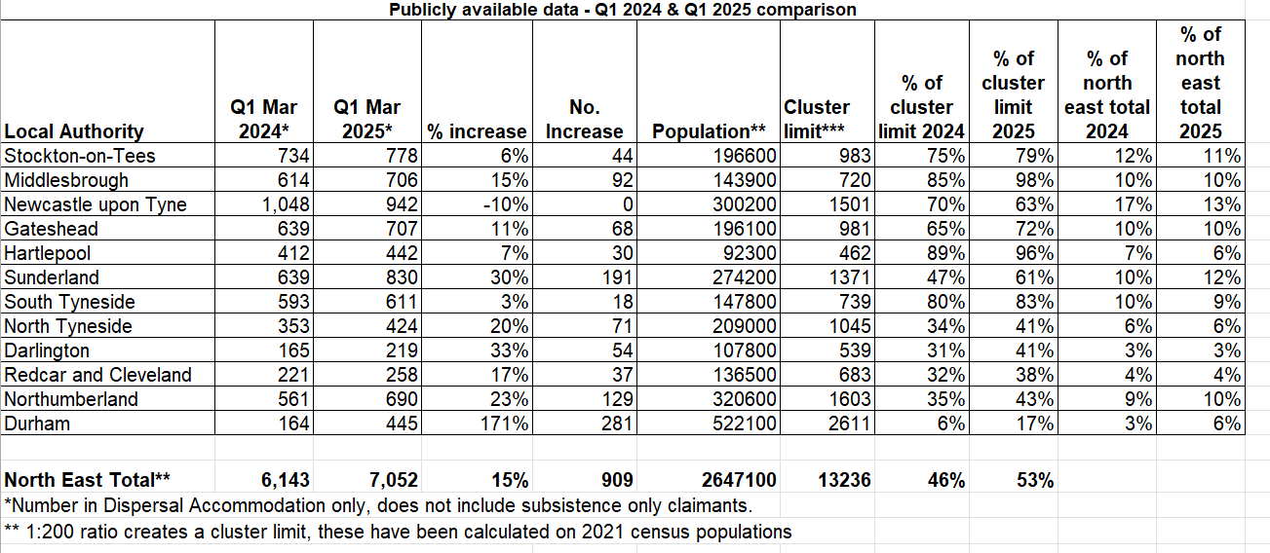

National Dispersal, Initial and Cotingency Accommodation Data
As of the end of Q1 2025, the North East housed 7% of the national total of asylum seekers who were in reciept of support in Dispersal, Initial and Contingency Accommodation. Below is a national breakdown.
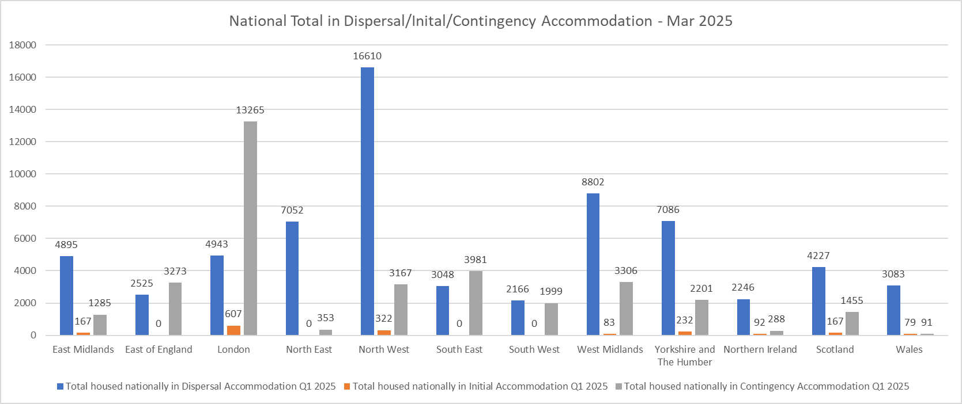

North East Contingency Accommodation Data
As of the end of Q1 2025, the North East housed 353 asylum seekers who were in receipt of support in Contingency Accommodation. Please see below for a regional overview.

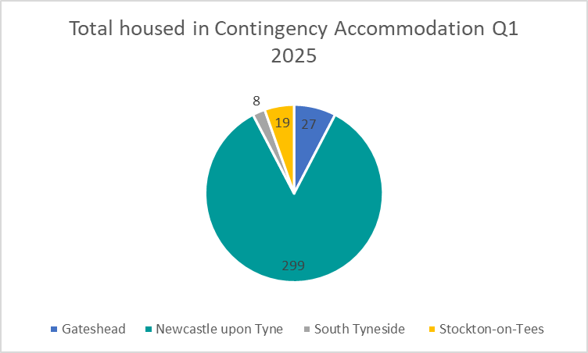

Hong Kong BN(O) Welcome Programme
Immigration Statistics
New data on the Hong Kong BN(O) scheme was published as of March 2025, and can be accessed here. In total, there have been 179,258 grants since the scheme opened on 31 January 2021. During the first year, visa grants peaked at 75,579. Numbers have fallen every year since. On the BN(O) route, since its introduction to the end of March 2025, there have been a total of:
- 185,478 out of country visa applications
- 179,258 out of country visas granted
- 163,400 people have arrived in the UK (rounded)
- 47,020 in-country extension applications
- 44,646 in-country extensions granted
In Q1 2025, there has been 2,544 out of country visas granted, which has equated to 2,200 arrivals in the UK.
Hong Kong Welcome Program Year 5
The Government announced Year 5 of the Hong Kong Welcome Program on Thursday 20 March 2025. The program will include:
- Grant funding the Mental Health and Wellbeing (Barnardo’s) project for an additional 6 months (until September 2025). See details of this project here.
- Continuing funding for the network of 12 Welcome Hubs across the UK, helping BN(O)s understand and connect to services in their local area.
- Further funding for On Your Side, a hate crime reporting and support service for BN(O)s and all other East and Southeast Asian communities in the UK who experience or witness racism or any other form of hate (funded until March 2026).
- Continuing funding for English language classes, and destitution support if needed, provided through local authorities in England. Further details can be found here.
- Continuation of dedicated GOV.UK page, including Welcome Pack, available in English and Cantonese.

Unaccompanied Asylum Seeking Children (UASC)
NTS Publicly Available Data
The table below compares the number of unaccompanied asylum seeking children who transferred into North East local authorities in Quarter 1 over the past four years. The figure has risen by 12% to 28 children in the first quarter of 2025 compared to 25 children in 2024 however this figure is significantly lower than the same period in 2023.

Transfers completed under the National Transfer Scheme, Q1 2022-2025
 | Q1 2022 | Q1 2023 | Q1 2024 | Q1 2025
County Durham | 6 | 16 | 4 | 5
Darlington | 2 | 2 | 1 | 0
Gateshead | 3 | 4 | 2 | 1
Hartlepool | 1 | 0 | 0 | 2
Middlesbrough | 0 | 1 | 2 | 1
Newcastle upon Tyne | 1 | 2 | 2 | 5
North Tyneside | 3 | 2 | 0 | 2
Northumberland | 2 | 1 | 0 | 3
Redcar & Cleveland | 5 | 10 | 4 | 2
South Tyneside | 3 | 2 | 2 | 2
Stockton on Tees | 3 | 2 | 6 | 3
Sunderland | 0 | 3 | 2 | 2
Total | 29 | 45 | 25 | 28

NTS Funding
The Home Office has confirmed the UASC funding tariff and incentivised funding offers for the 2025/26 following consultation with local authorities and SMPs to discuss the success of previous incentivised funding offers and gathered feedback to inform future offers.

The new funding includes the below:

- As of 1 April 2025, all local authorities are eligible for £143 per child per night payment for all UASC within their care. Previously, only local authorities above their 0.07% threshold who transferred children through the NTS would be eligible for the higher payment rate. Those below the threshold would be paid £114 per child per night.
- From 14 April 2025 to 31 October 2025 local authorities that transfer children through the NTS within five working days will be eligible for £5,000 additional funding per child.
- From 1 June 2025 to 30 September 2025 local authorities that transfer children through the NTS within two working days will be eligible for £10,000 additional funding per child.

Both incentivised funding offers are available for children who transfer from any local authority via the NTS, previously only transfers from Kent County Council were eligible. The incentivised funding aims to allow local authorities to build capacity during the summer months to ensure children can transfer through the scheme as quickly as possible as waiting to transfer can cause significant impacts on their mental health and block beds for the children who are arriving into the UK.

Welcome Resources
NEMP has created two Welcome Guides to help Unaccompanied Asylum Seeking Children feel welcomed to the North East. The guides are designed to be shared with young people before they arrive to the region so they are provided with useful information on activities, local support services and places of worship.

NEMP will be translating the guides in the coming months to ensure as many young people as possible to access the information. NEMP is also going to be working with a local VCSE organisation to produce further welcome materials for young people when they first arrive into the region.

Ukraine Schemes
Ukraine Permission Extension Scheme
The Home Office has made amendments to the Immigration Rules, announcing that the Ukraine Permission Extension Scheme is open for applications from 4 February 2025. The Ukraine Permission Extension (UPE) scheme allows those already on the Ukraine Schemes to extend their stay on the route. Live data on the UPE scheme was provided as a response to a question by Seema Malhotra on 15 May 2025 (see here and below), however further data can be found in the updated Immigration Statistics published as of March 2025, accessed here.

- Applications received – 53,870
- Applications processed – 45,576
- Applications approved – 44,105
- Applications withdrawn – 1,321
- Applications rejected or refused – 150.

These figures have been taken from a live operational database. As such, numbers may change as information on that system is updated. No information has been given regarding reasons for rejections or refusals. As more people become eligible for UPE in the coming months, numbers will increase.

National Data
As of 31 March 2025, 272,945 visas have been granted on the Ukraine Schemes. Following the introduction of the schemes in 2022, there were 209,706 visas granted during the first year, falling to 40,287 in the second year. Visas have continued to gradually fall over the last few years. Further information can be found here.

National discussions have suggested that many local authorities are concerned with the number of Ukrainian visa holders on a Ukraine Scheme visa, that are applying for asylum instead of the UPE scheme. Data released on 21 May 2025 shows that 676 in-country asylum claims have been made by Ukrainians in Q1 2025, compared to 75 in Q1 2024. Further information can be found here.
Ask Hanna
NEMP has purchased 50 Ask Hanna memberships for Ukrainian guests and arrivals in the North East region. Ask Hanna is a comprehensive support service provided by Refugee Host Support for Ukrainian speaking refugees. It provides peer support, 24/7 advice line, short-term counselling, podcasts on work-life topics and more. NEMP has developed a referral pathway for VCS organisations and health providers, and local authorities. If you would like to know more about the service and how to make a referral, please contact nemp@middlesbrough.gov.uk as we are keen to ensure this free service is well utilised.

Refugee Resettlement
UKRS
This research article looks at how the experience of resettlement affects family dynamics and parenting practices for Syrian families in the UK. It explores the challenges of culture shock and obstacles to integration, and how this is reflected in maintaining cultural values and parental authority in a new environment.

UNHCR has created a guide on the current crisis in Syria and what happens to displaced people. After over a decade of conflict, Syria remains one of the world’s largest refugee crises. Since 2011, more than 14 million Syrians have been forced to flee their homes in search of safety. More than 7.4 million Syrians remain internally displaced in their own country where 70 percent of the population needs humanitarian assistance and 90 percent live below the poverty line. More than 6 million Syrian refugees live in countries neighbouring Syria including Türkiye, Lebanon, Jordan and Iraq or abroad.

Afghan Resettlement
Thrive London has developed a guide to support the mental health and wellbeing of Afghan refugees, as well as resources which can be used by both practitioners and Afghans directly. There is a "Help with your concerns or worries" guide following events in Afghanistan which can cause a great deal of concerns for displaced refugees. Here, Thrive outlines tools and and ideas encouraging good mental health and wellbeing, alongside some useful ways to get support or access healthcare services if you are finding things hard. The guide is available in English, Dari and Pashto.
The guide also incorporates some extracts from London’s digital wellbeing service, Good Thinking’s ‘Five ways to good mental wellbeing and Islam’ resources to helpfully show how many of the ideas are encouraged in Islamic teachings. It is well worth organisations taking a look and encouraging the use.

This article describes issues and concerned faced by the Afghan population overseas, particularly in Iran as they face deportation and forcible removal from Iran. It also provides an overview of historical and contemporary forced migration from Afghanistan to Iran.

As the global population of refugees increased to a record high 37.8 million as of mid-2024, a staggering 16 percent—nearly one in six—originated from Afghanistan, where they have fled several decades of civil war, persecution, and state collapse. Almost 90 percent of the world’s 6.1 million Afghan refugees live in neighbouring Iran or Pakistan, with Iran hosting the largest share. In fact, as of mid-2024, Iran was the world’s largest refugee host, sheltering 3.8 million people, of whom 99 percent were from Afghanistan, alongside small numbers from Iraq and other countries. Over the past four decades of conflict and war in Afghanistan, Iran has remained a key destination for different cohorts of Afghans, many of whom subsequently left when home-country conditions improved, due to its geographic proximity and shared language and cultural ties—especially with Dari-speaking and Shia Muslim communities such as the Hazara ethnic group.

UNHCR details concerns about Afghan refugees forced to return facing an uncertain future. In the month of April, more than 280,000 Afghans were pressured to return home or were deported from Pakistan and Iran. Many arrived with nothing and urgently need help to restart their lives. Most have arrived at Torkham and other border points after being forced or pressured to return following the resumption of Pakistan’s Illegal Foreigners Repatriation Plan, originally launched in late 2023. In April alone, some 144,000 Afghans returned from Pakistan, including nearly 30,000 who were deported. Many are arriving to a country they left decades ago, or have never known, with few belongings and no idea what their future holds.

Ezatullah, 45, crossed the Torkham border into Afghanistan recently with his wife and seven children. “They told us to leave urgently,” he said. “All of our belongings were left behind; everything was lost. We now have nothing.”

He was born in Pakistan and spent his entire life there, earning a modest living as a labourer in Rawalpindi. He has no idea where he and his family will go or how he will care for his children in a country where unemployment and poverty have surged in recent years, leaving half the population dependent on aid to meet their basic needs.

Table 3 – Total Resettlement Arrivals into the North East since 2021

Local authority | UKRS Arrivals Since 2021 | Afghan Resettlement Programme Arrivals since 2021 | Total Resettlement Arrivals since 2021
County Durham | 82 | 195 | 277
Darlington | 0 | 22 | 22
Gateshead | 36 | 155 | 191
Hartlepool | 17 | 174 | 191
Middlesbrough | 2 | 101 | 103
Newcastle upon Tyne | 41 | 115 | 156
North Tyneside | 12 | 65 | 77
Northumberland | 0 | 139 | 139
Redcar and Cleveland | 84 | 78 | 162
South Tyneside | 0 | 49 | 49
Stockton-on-Tees | 0 | 81 | 81
Sunderland | 0 | 28 | 28
Total | 274 | 1202 | 1476

ESOL & Employability
Refugee Employability Programme
The Home Office commissioned Refugee Employability Programme contract did not get extended. The delivery for service users finished on 10 June 2025, with no new start since 10 December 2024. Some service users will have received 18 months support, some service users may have only been accessing support from December until June.

In NE, the programme engaged with 2,297 potential service users, 1,267 joined programme. From end of March 2025, 392 separate individuals have started jobs, 27 of those are self employed. 216 have remained in work post 3 months. The most common working sectors are manufacturing, hospitality and food, retails and sales.

Displaced International Recruits
Open Door North East and Action Foundationare providing support for displaced international recruits. Support covers four key areas; Needs assessment, health and wellbeing, skills and knowledge and guidance and coaching. Employability support includes counselling and planning. Technology and resources, applications and skill development and job searches. Ongoing support includes navigating complexity, meeting expectations, securing new role and being a point of contact. For anyone working with clients who require support, they can self refer using this link: https://forms.office.com/e/iDvCTK6kYy?origin=lprLink

On 4 June 2025, the Association of Directors of Adult Social Services (ADASS) hosted The North East International Recruitment Conference, which provided an opportunity to learn from keynote speakers and a Q&A panel about the current support offer available for international recruits in the North East within Adult Social Care services.

The purpose of the event was to;
- Spotlight the work being done across the North East to support displaced international workers in Adult Social Care
- Share best practice on the support offered to displaced international workers in Social Care
- Bring together the community of colleagues and peers engaged in supporting international workers in Social Care
- Focus on the positive impact international recruitment and recruits bring to the NE Social Care workforce
- Provide free legal surgeries around international recruitment for social care providers to attend.

The Bell Foundation update on 2025 immigration white paper
The Bell Foundation’s Director Diana Sutton published an article about the implications of The Governments Immigration White Paper on English as a Second Language (ESOL) provision, and how the new English language requirements ignore a deeper crisis in ESOL investment across the UK. The article emphasises one important fact that is overlooked: one in three people who report not being able to speak English well or at all are UK citizens – not migrants. You can find the article here.

NATECLA Annual Conference
The annual NATECLA conference is the leading event in the ESOL teaching calendar and has been for over 25 years. It is an opportunity to join ESOL and ELT practitioners from all over the UK and Ireland to engage in talks and workshops, discussion and ideas-sharing sessions, a diverse exhibition area and relaxed social activities. The conference will be held on Friday 27th – Saturday 28th June at Conference Aston, part of the Aston University campus in Birmingham. More information on the conference can be found here.

ESOL for under 19’s
NEMP is looking to pilot an online ESOL provision for those under 19 and unable to access a college place, working in partnership with Northumberland County Council. The offer will also include enrichment activities for young people who will come together in a single location to support each other and avoid the potential isolation of “online” learning. NEMP is specifically looking to work with organisations who can support with trauma and mental health difficulties as part of the enrichment sessions and is hoping to have the offer in place for 2025. This fits for those who do not gain a place in college in the new term intake. If you would like any further information on this offer, if your local authority has similar issues, or you know anyone who could help with enrichment, please contact nemp@middlesbrough.gov.uk.

Scholarships
Over 80 universities offer scholarships, bursaries and fee waivers for people who have claimed asylum in the UK. Each scholarship has different eligibility criteria, application deadlines, and levels of financial support. You can find further information here.

For the North East, University of Sunderland still has bursaries available for undergraduate courses open to asylum seekers, those who have limited leave to remain (LLR) or discretionary leave to remain (DLR), humanitarian protection and those who hold refugee status. Applications for these scholarships close on 31 August 2025.

ESOL support service
The Newcastle ESOL Service has been running for 15 months and in that time has seen more than 1200 people with ESOL needs. The service is run by the ESOL Lead who also regularly meets with ESOL providers and organisations that work with current and potential ESOL learners to build up a bigger picture of what is on offer in Newcastle and what is missing. The ESOL Service has helped to set up several new community classes and facilitated others to expand their provision with more to come in 2025-26.

ESOL assessments take place at Jobcentre Plus venues in Newcastle and there are weekly bookable appointments and a drop in at Work & Thrive Central at Newcastle City Library every Thursday. The service has recently expanded to offer assessments and referrals at additional venues across the city and the ESOL Lead is more than happy to arrange off-site assessments and referrals for partner organisations.

For more information, please visit Language Support | Work and Thrive Newcastle or contact Ian Raby directly at ian.raby@newcastle.gov.uk. The Newcastle ESOL Service will be happy to meet potential learners from other parts of the North East as well as Newcastle.

NEMP Website
Please access the NEMP website by clicking here. NEMP continues to update the various hubs with information, updates and resources, such as our Welcome to the UK guides, guidance and advice, which we hope you will use. The website also includes our local service directory, which is in the process of being updated for all local organisations and the services they offer. Please also make use of the welcome resources too with groups or individuals you are supporting. If you have any suggestions for the NEMP website or would like to update a service on the directory, please get in touch by emailing nemp@middlesbrough.gov.uk.

Health
UKHSA Health Inequalities in Health Protection Report 2025
The UKHSA Health inequalities in health protection report 2025 was published on 2nd May and can be found here. It provides a high-level description of the current state of inequalities in health protection in England, focusing on three dimensions of inequality: people living in different areas of deprivation, people from different ethnic groups, and geographical inequalities. It covers infectious disease (predominantly using emergency hospital admissions as an indicator), and environmental hazards.

The Mental Health of Asylum Seekers and Refugees in the UK 2025
The first edition of this report was published in February 2024 by The Mental Health Foundation which presented evidence on the economic, social, and cultural circumstances which asylum seekers and refugees who seek sanctuary in the UK can face, and how these experiences can harm their mental health. The report approaches these challenges through the lens of public mental health which focuses on the improvement of mental health and wellbeing though preventative work involving communities, organisations, and individuals. The report can be accessed here.

Modern Slavery
Lived Experience Directory
A new UK Lived Experience Directory, developed by Survivor Alliance and the Modern Slavery & Organised Immigration Crime Unit, connects organisations with consultants who have lived experience of modern slavery. Consultants can contribute their expertise to training, policy, and events. The searchable directory is now live and open to registered users. Access and guidance, including compensation information and the user application, are available here.

National Referral Mechanism Q1 2025 Statistics
The Home Office has published the National Referral Mechanism (NRM) and Duty to Notify Statistics for the first quarter of 2025. From January to March, 5,297 referrals were made, marking a record high for UK and Vietnamese nationals. Albanian nationals were not among the top three for the first time since 2014. Additionally, 1,609 adult potential victims were reported via the Duty to Notify process, the second highest quarterly figure on record. View the data here.

Barriers to Prosecutions and Convictions under the Modern Slavery Act 2015
A new report by Modern Slavery PEC highlights a major gap between the number of potential victims and successful prosecutions under the Modern Slavery Act. From July 2023 to June 2024, 17,120 people were referred to the National Referral Mechanism across the UK. Yet only 114 defendants were formally charged with modern slavery offences in England and Wales, resulting in 58 convictions. While 467 cases were flagged as modern slavery related, challenges remain in securing justice for survivors. The report calls for improved support for survivors and greater resources for law enforcement. Read the report here.
Refusal to Consent Report
This new report, published by The University of Nottingham's Right Lab and the Independent Anti-Slavery Commissioner's Office identifies a wide range of factors which may influence the decision not to consent to referral into the National Referral Mechanism (NRM). Influencing factors included fear of immigration repercussions and authorities, fear of exploiters, the inconsistent description and lack of understanding of the NRM, the questionable benefit of the NRM beyond formal recognition, and impacts from recent policy and legislation. The report makes several recommendations, including standardised training for First Responders, pre-NRM safe spaces and further survivor-led research. Read the report here.
Modern Slavery Act: Ten Year Review
In March 2025, the Home Affairs Committee held a parliamentary session reviewing the Modern Slavery Act's impact over the past decade. The session explored issues around identification, support, capacity, resources, and prosecutions. Following the session, the Committee's Chair, Dame Karen Bradley MP, wrote to Minister Jess Phillips regarding some of the key points raised during the session, including calls for more cross-government and multi-agency coordination, clearer definitions, and a greater emphasis on providing timely, trauma-informed support for survivors. The Minister's response addresses how the government plans to act on these concerns. Read Dame Karen Bradley's letter here and Minister Jess Phillips' response here.

No Recourse to Public Funds (NRPF)
The Care Rights Project provide free advice and advocacy to migrants with no recourse to public funds
The Care Rights Project has excellent resources and is valuable to anyone who encounters people with NRPF who also has eligible care and support needs.

A person’s care and support needs will be considered eligible if:
• They are due to a physical or mental illness or disability, and
• The person can’t manage at least two key daily activities because of these needs, and
• This is having (or likely to have) a serious effect on their wellbeing.

You can find more details here - Resources for Advisers and Professionals — The Care Rights Project

NRPF Training
The NRPF Network has are lots of expert training opportunities available for councils on supporting people with no recourse to public funds and good practice in delivering services. To find out more, visit: Training | NRPF

NRPF News
RTPF Checker | NRPF
The Recourse to Public Funds (RTPF) Checker is now available to councils across the UK to subscribe to in order to instantly establish whether a person can access public funds (benefits and local authority housing assistance). The Home Office has funded the development of the RTPF Checker, which will be operated by the NRPF Network after the successful integration of the RTPF Checker into NRPF Connect.

As the eVisa roll-out continued, it became apparent that a standalone RTPF Checker service was necessary for other services that need to confirm a person’s immigration status and/or ability to access public funds in order to determine their eligibility, where a person is experiencing problems accessing their eVisa account via ‘view and prove’ or does not yet have an eVisa account.

The RTPF Checker now answers the need for a light-touch immigration verification service, with the same attention to information security and ongoing technical support as already enjoyed by users of NRPF Connect.

White paper | NRPF
This article explores the impact of the government has published an immigration white paper proposing a broad range of changes to the UK’s immigration system and how this will impact those with no recourse to public funds; both positive and negative impacts of the changes are explored.

What’s Going On - Refugee Week 2025
NEMPs Lunch and Learn Events
This Refugee Week, NEMP is hosting a series of Lunch and Learn sessions online via Microsoft Teams, taking place every day from 16th – 20th June. This year’s theme “Community as a Superpower” celebrates the strength and connection found in community. Each session will explore culture, community, and belonging for migrants in the North East. Please find the poster attached below alongside additional information about each available session.

The following sessions are especially designed for professionals working across health, education, local government, policing, and refugee support:

- Monday 16th June, 12pm – 1pm | Welcome to Ukraine: Cultural Awareness Session
To introduce participants to Ukrainian culture and values to support interactions with Ukrainian refugees, to understand the ways they have adapted or integrated cultural traditions whilst creating a community away from home. Target audience: Professionals from local authorities, VCS groups and external partners that want to learn more about Ukrainian culture and the ways it has manifested in the UK.

- Tuesday 17th June, 12pm – 1pm | Asylum in the North East: The Power of Community and Integration
Explore how community can be a source of strength and inclusion and identify local examples of community power in action. Target audience: Professionals from local authorities, VCS organisations and external partners/stakeholders who are interested in promoting community and cohesion in their local area.

- Wednesday 18th June, 12pm – 1pm | Refugee Journeys: Understanding Refugee Resettlement in the North East
To share knowledge and learning of the resettlement journey and understanding cultural differences and experiences. Target audience: Professionals from local authorities, VCS groups and external partners that want to learn more about Resettlement and/or the Afghan Community.

- Thursday 19th June, 1pm – 2pm | From Arrival to Belonging: Fostering Community for Unaccompanied Children in the North East
To introduce participants to the journey of unaccompanied children, the experience of fostering a UASC and the community of young people that has been built in the North East as a result of the NTS. Target audience: Professionals from local authorities, VCS groups and external partners that want to learn more about UASC.

The following session is for migrant communities, refugees and asylum seekers who reside in North East and are interested in learning about the local dialect and culture.

- Friday 20th June, 12pm – 1pm | Discovering the North East: Understanding Local Dialect and Culture.
To introduce participants to the unique dialect and cultural nuances of North East England, helping them feel more connected and confident in their new community.

If you would like to sign up to attend any of the sessions, please email nemp@middlesbrough.gov.uk to register.

'Seeking Asylum in the UK: Challenges, Hopes, and Realities'
The Institute for Economic and Social Inclusion is organising a panel discussion for Refugee Week in Sunderland titled 'Seeking Asylum in the UK: Challenges, Hopes, and Realities'. The event will take place on 19th June from 4:00pm-5:20pm at Hope Street Xchange, Enterprise Suite, Hind Street Sunderland SR1 3QD and features a panel of expert speakers. The event aims to bring together experts from academia, the voluntary and community sector and the refugee community to share perspectives on the challenges and lived experiences of claiming asylum in the UK. For more information or to sign up, click here.

Migrant Help Update
Please see Migrant Help’s most recent newsletter here which includes updates on safeguarding, outreach, move on and more as well as alternative ways to contact them if you are experiencing long wait times when calling their generic telephone number. The main ways to contact are the webchat, raise an issue via their website or the freephone.
- Webchat
- Raise an Issue via our website
- Freephone helpline - 0808 8010503

Funding Opportunities
NEMP also provide and circulate a regular round-up of known funding opportunities, please see the most recent one attached below for a full list of current grants.

Please email nemp@middlesbrough.gov.uk if you would like to be added to the circulation list, or note something we have missed.

News and reports
Restoring Control Over the Immigration System: White Paper
The White Paper introduces plans to reform the UKs immigration framework, aiming to address the unprecedented net migration levels, which peaked at approximately 906,000 in mid-2023, and to realign immigration policies with the UK’s economic and social objectives. The White Paper can be accessed here. The core principles are detailed below:
- Reduce net migration: Ensure migration levels are controlled and manageable.
- Link to UK skills needs: Align immigration with domestic training and skills requirements, avoiding over-reliance on foreign workers.
- Fair and clear rules: Make the system transparent and effective, with Parliament-defined rules, especially around family life.
- Enforce the rules: Strengthen enforcement, including tackling illegal work and deporting foreign criminals.
- Promote integration: Support community cohesion through English language requirements and assessing migrants’ contributions.

Chartered Institute of Housing (CIH) – Spring 2025 Newsletter
The latest newsletter from the CIH is now available and covers many subjects, including:
- Asylum accommodation and local connection: it’s complicated!
- New refugees need help to find secure housing
- London’s asylum move-on liaison officers are a step in the right direction
- Specialist supported housing: A safety net for separated migrant children
- Building futures: Supporting refugee and asylum-seeking families to thrive
- Population growth now depends upon migration – how does this affect housing demand?

Women for Refugee Women, Safety and Survival: How the Work Ban Fuels Violence Against Women Seeking Asylum: The report details their research findings to explore how the ban in being able to work is having a negative impact on many different aspects of the lives of women seeking asylum. The research highlighted shocking new findings and found that women who have fled gender-based violence, including rape, domestic violence, forced marriage and sexual exploitation, are forced into exploitative and harmful situations where they are vulnerable to violence and abuse, as a result of the work ban placed on asylum seekers.

Community Volunteer Roles: The North East Ambulance Service
The North East Ambulance Service have been working with disabled and ethnically diverse communities to create community ambassador roles, which are open to anyone in the community with no exclusions. The positive action project helps volunteers to use their links within their community to share key messages from the North East Ambulance Service. They deliver workshops free of charge and cover the following:

• How to use their services
• Tools available to help access services
• Employment and volunteering opportunities
• What happens when you call 111/999
• What to do during an emergency
• How to perform CPR
• How to use a defibrillator

The North East Ambulance Service also deliver employment workshops on a quarterly basis to help people understand the NHS job search to interview process. These are delivered once a quarter online and are suitable for those who are actively looking for work.

For further information on how to become a community ambassador, click here, or email loveness.scott@neas.nhs.uk to sign up or ask any questions.

Positive News Stories
Afghan refugee family’s ‘taste of home’ is a recipe for success | North Yorkshire Council
An Afghan family from Northallerton are planning to stage more events after dozens of people attended a pop-up restaurant that showcased authentic cuisine from their homeland. The family has been living in Northallerton for the past two years and has demonstrated “resilience and determination” in adapting to new circumstances as well as integrating in the new community.

They staged the pop-up restaurant at Northallerton Town Hall on Saturday 19 April, to say thank you to local communities who have helped them to rebuild their lives and put down roots in North Yorkshire. Dishes which were served up include authentic Afghanistan cuisine from kabuli pilau (a national Afghan rice dish with lamb), chicken karahi, Afghan kofta, lubya (bean stew), to much more.

Refugee goalkeeper Fahd Saleh 'over the moon' to coach for England - BBC News
Fahd Saleh was a professional goalkeeper at one of Syria's top football clubs before fleeing the civil war. He now works with under-15 players at the FA's St George's Park training ground in Staffordshire and will join them at the Vlatko Marković International Tournament at Čakovec in Croatia next week. Fahd said he was "absolutely buzzing" to be coaching national players and felt very proud to wear the team's three lions badge on his shirt.

Refugees given cycle training in East Riding to help them settle - BBC News
East Riding of Yorkshire Council's road safety team organised the two-day Refugee Cycle Project at the East Riding Leisure Beverley centre in Flemingate for 16 people. The project was set up to give men or women of all ages who were originally from Syria, Afghanistan and Ukraine the chance to travel around the region more independently as they build new lives. Councillor Paul West said the project had made a "positive impact" to people's lives.

The refugee nurse whose smile lights up a Teesside hospital | The Northern Echo
Read about the young Palestinian refugee, Aya Yassin, who is proving to be an asset to the National Health Service (NHS. It is almost two years since she made a “life-changing” journey from Lebanon to England to take up a role in the Accident and Emergency department of The James Cook University Hospital, in Middlesbrough. Aya talks about the peace and happiness she has found as a nurse in the NHS.

Open day at the Nasir Mosque in Hartlepool
The Nasir Mosque on Brougham Terrace in Hartlepool held an open day on Saturday, 3 May. The Mosque was a focus of attention during a night of rioting on 31 July 2024 after the wave of disorder that spread across the UK following the Southport stabbings and anti-immigration-fuelled social media misinformation. Race rioters tried to target the Mosque. Fortunately, the police blocked off both ends of Brougham Terrace, and the rioters went elsewhere. The purpose of the open day was to attempt to dispel some of the fears and misconceptions about Islam.

Middlesbrough: an immigrant town and a community fighting back
Following last year’s riots, MP Andy McDonald reflects on Middlesbrough as an immigrant town and calls on people in the area to use their people power, their police, their courts, their brooms and brushes, their shared sense of history that everybody in Middlesbrough came from somewhere else and make sure nobody is in any doubt about what the area is about.

If you have received this newsletter via a colleague and would like to receive it directly, or if you would like to unsubscribe, or have any comments or suggestions for future content, please contact nemp@middlesbrough.gov.uk.

