

North East Migration Partnership Newsletter September 2025
The NEMP (North East Migration Partnership) Newsletter brings together various sources of information, which relate to Refugees, Asylum Seekers, and Migration in the region. If you have any suggestions for additional content, please email: nemp@middlesbrough.gov.uk. We hope you enjoy reading it, any feedback you have will be welcomed so we know if we are hitting the right spot or not.
CONTENTSs
Asylum Updates 1
Asylum – Home Office Statistics 2
Hong Kong BN(O) Welcome Programme 4
Unaccompanied Asylum Seeking Children (UASC) 5
Ukraine Schemes 6
Refugee Resettlement 6
ESOL & Employability 8
NEMP Website 10
Health 10
Modern Slavery 10
No Recourse to Public Funds (NRPF) 11
Migrant Help Update 11
Funding Opportunities 12
News and reports 12

Asylum Updates
56-day Move On Pilot
In July 2025, the Home Office confirmed that the 56-day Move On pilot will be extended until December 2025. However, the Home Office has now most recently updated that from 1st September 2025, the pilot will now pause for all single adults who are in receipt of a positive asylum decision (with the exception of those who are pregnant, over the age of 65 or have a known/evidenced disability, as defined by the 2010 Equality Act). The independent evaluation of the pilot being conducted by NatCen and RSM continues and is due to conclude in the upcoming months.

Home Office Asylum and Immigration Briefing note
The Home Office has produced a briefing note following the Home Secretary’s Oral statement on 1st September to aid reporting. Please see linked here.

Family Reunion Scheme
The government is temporarily suspending new applications for the Family Reunion Scheme allowing refugees to bring their family members to the UK. This means that restrictions will be in place to those hoping to bring their family to join them in the UK. This generally means someone must earn at least £29,000 a year and provide suitable accommodation, while their family member may need to demonstrate a basic level of English. More information can be found in this briefing note here. Existing applications already in the system will continue to be processed in the normal way. The pause does not affect refugees' existing rights or those who have already been granted reunion visas.

The UK-France small boats returns deal and options for further cooperation with the EU
The Migration Observatory has published information on the UK-France small boats return deal, available here.

The UK and France agreed to a reciprocal arrangement – returning some small boat arrivals from the UK to France, while accepting an equal number of asylum seekers from France. The aim of the scheme is to deter people from taking this dangerous route. For those wishing to apply to come to the UK from France, they will have to complete an expression of interest form for the UK/European Applicant Transfer Scheme (more information available here).

Myth Buster resource
NEMP has been working with the Offices of the Police and Crime Commissioners (OPCC’s) for the North East (Durham, Northumbria and Cleveland police) to collate and update a Myth Buster resource, aiming to address and debunk common asylum and migration myths. The original resource was published in 2015 and while it aimed to address some commonly believed myths that are still relevant today, a lot of the information was outdated and in need of accurate statistics. NEMP has now updated the information to create a more accurate version to challenge outdated asylum and migration views and provide true facts and statistics to help highlight false information. It can be found on the NEMP website here.

The information is also being summarised to generate a two-page physical leaflet that will be circulated by the OPCC’s shortly. If you wish to get involved with the launch and promotion of the Myth Buster materials, please email nemp@middlesbrough.gov.uk.

e-Visa updates
The guidance on e-Visa support has been updated here on GOV.UK. These updates include additional funding announced for community support and making a new application to enter and stay in the UK from 15 July 2025.

Asylum – Home Office Statistics
To access the raw publicly available information, click here. This information can also now be viewed on our data page on the NEMP website, here where we have provided some analysis for stakeholders to use to support funding bids.

North East Dispersal Accommodation Data
As of the end of Q2 2025, the North East housed 6,891 asylum seekers who were in receipt of support in Dispersal Accommodation. Below is a breakdown with a comparison of Q2 2024 to Q2 2025.

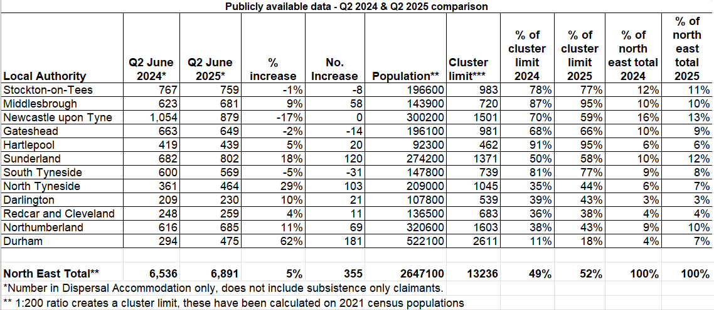

North East Contingency Accommodation Data
As of the end of Q2 2025, the North East housed 326 asylum seekers who were in receipt of support in Contingency Accommodation. Please see below for a regional overview.

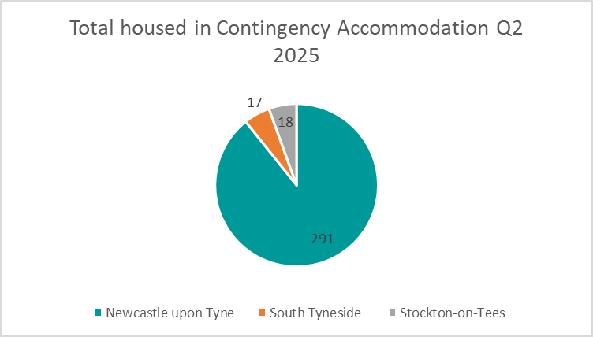

National Dispersal, Initial and Contingency Accommodation Data
As of the end of Q2 2025, the North East housed 7% of the national total of asylum seekers who were in reciept of support in Dispersal, Initial and Contingency Accommodation. Below is a national breakdown.

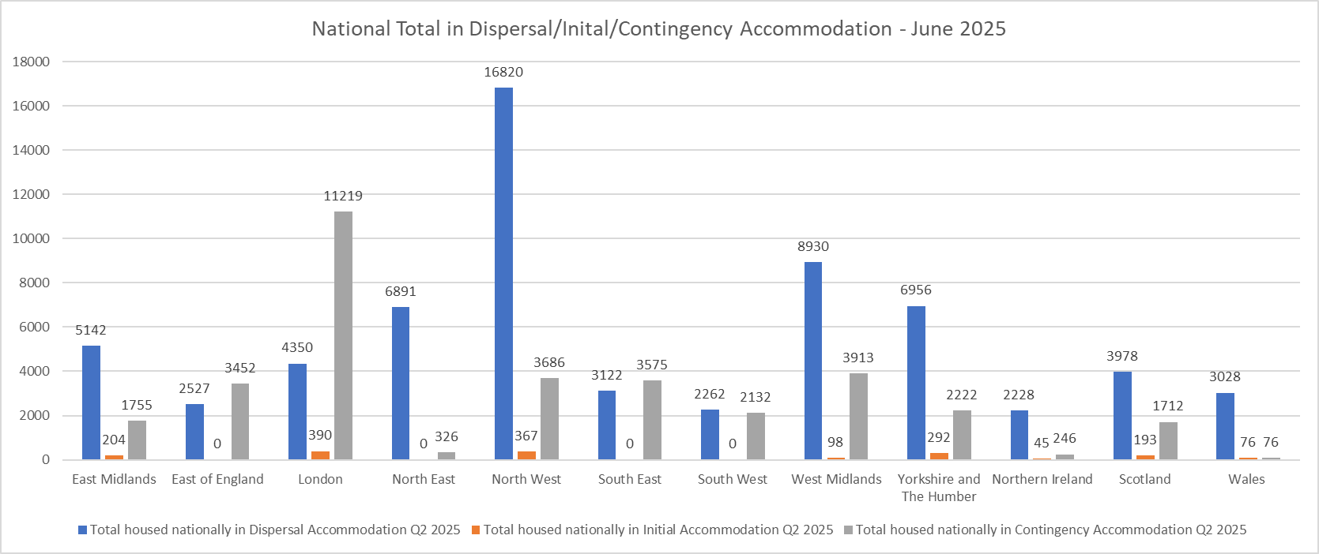

Hong Kong BN(O) Welcome Programme
North East Hongkongers Club
The North East Hongkongers Club continues to welcome new arrivals into the region, providing a range of activities in-person and online. In July, they had a productive working party at the community garden in Jesmond, where they shared their self-grown fruit and vegetables. They also went to a local church in west Northumberland to do some volunteer work for the local people. Upcoming events can be found here.

Hong Kong BN(O) Scheme Data
On the BN(O) route, since its introduction on 31 January 2021 to the end of June 2025, there have been a total of:

188,273 out of country visa applications, with 11,168 in the year ending June 2025
181,609 out of country visas granted, with 11,804 in the year ending June 2025
166,300 people who have arrived in the UK (rounded), with 15,700 in the year ending June 2025
46,780 in-country extension decisions, (total of grants and refusals), with 6,845 in the year ending June 2025
46,256 in-country extensions granted, with 6,746 in the year ending June 2025

Nearly 600 individuals on the BN(O) route were granted settlement in the year ending June 2025. Please note, this figure is composed of people who moved onto the BN(O) route from another visa which counts toward 5-years residency. BN(O) visa holders that were granted a visa in January 2021 will be eligible for settlement in January 2026. Further data on the Hong Kong BN(O) scheme can be found here.

Joint Foreign Secretary-Home Secretary statement on Hong Kong announcing new arrest warrants for overseas activists
On 25 July 2025, the Foreign Secretary and Home Secretary issued a response after Hong Kong announced new arrest warrants for overseas activists. The statement included changes made to the UK’s Extradition Act 2003, severing ties between the UK and Hong Kong extradition systems by removing Hong Kong from this act. The full statement can be found here.

Parliament Debate on 5-year ILR terms to Hong Kong British National (Overseas) visas
On 8 September 2025, parliament debated the changes outlined in the Immigration White Paper, specifically those changes which could impact the 5-year route to settlement for the Hong Kong BN(O) community; extending ILR terms to ten years and increasing the English proficiency level from B1 to B2. This debate is available to watch online on YouTube, here.

Unaccompanied Asylum Seeking Children (UASC)
NTS Publicly Available Data
The table below compares the number of unaccompanied asylum seeking children who transferred into North East local authorities in Q2 over the past four years. At 47 transfers, the figure is the highest it has been in recent years rising by 31% since Q2 2024. Nationally, 513 children transferred during Q2 with North East local authorities responsible for 9% of NTS transfers.

Transfers completed under the National Transfer Scheme, Q2 2022-2025
 | 2022 Q2 | 2023 Q2 | 2024 Q2 | 2025 Q2
County Durham | 7 | 6 | 8 | 13
Darlington | 4 | 2 | 1 | 6
Gateshead | 3 | 4 | 2 | 3
Hartlepool | 1 | 2 | 5 | 0
Middlesbrough | 1 | 2 | 2 | 1
Newcastle upon Tyne | 3 | 2 | 2 | 0
North Tyneside | 5 | 1 | 7 | 2
Northumberland | 2 | 2 | 2 | 6
Redcar & Cleveland | 0 | 2 | 4 | 7
South Tyneside | 8 | 2 | 1 | 0
Stockton on Tees | 7 | 1 | 0 | 3
Sunderland | 5 | 3 | 2 | 6
Total | 46 | 29 | 36 | 47

Abbreviated age assessments
Earlier in the summer, the Home Office updated the age assessment guidance to include new information on abbreviated age assessments. The changes have been made with the objective of safeguarding children who may be prosecuted or imprisoned as adults on immigration offences (for example, for facilitating illegal entry having been positively identified as piloting a small boat). The Home Office may conduct abbreviated Merton-compliant age assessments in certain immigration offence cases when individuals are treated as adults based on a "significantly over 18" decision and are identified for potential criminal charges. While typically carried out before arrest, exceptions exist for high harm offences or serious incidents requiring immediate action. The National Age Assessment Board will oversee this process, ensuring appropriate safeguards are in place.

The Needs of UASC in London report
The University of Bedfordshire, The London School of Economics and South London Refugee Association have jointly produced a report on The Needs of UASC in London. The researchers carried out in-depth conversations with 15 unaccompanied children placed in London to understand their experience of the asylum system. The report noted that young people found the asylum system long, uncertain and confusing and highlighted that quicker decision making would reduce costs for councils and allow young people to progress in their lives.

The report advises that deep-rooted reform is needed to prioritise the protection and well-being of young people and sets out a list of 38 recommendations to improve the system.

ICIBI inspection of age assessments
On 22 July 2025, the Independent Chief Inspector, David Bolt CBE, produced a report on the Home Office’s use of age assessments, the report noted that previous concerns about policy and practice in respect of initial age decisions remain unanswered and highlighted the lack of learning taken from decisions which are disputed and overturned.

The report set out eight recommendations which encourage the Home Office to work more closely and collaboratively with external stakeholders such as local authorities, SMPs and NGOs when designing and delivering processes. The Home Office has responded to the report and accepted all the recommendations, with several improvements already in train.

Ukraine Schemes
Further permission for Ukrainians in the UK
On 21 July 2025, the UK Government announced they will be extending Ukraine Permission Extension (UPE) leave beyond 18 months. This was confirmed on 1 September 2025, that it will be extended by a further 24 months. This is positive news for the Ukrainian community within the North East and nationally. The statement to Parliament can be found here.

UKVI Helpline Decommissioned
The UK Visas and Immigration (UKVI) service is decommissioning the dedicated Ukraine helpline numbers and consolidating customer contact through the main UKVI helpline: 0300 790 6268.

Currently, there are three separate numbers in use for the Ukraine helpline:
- 0300 303 2785
- +44 808 164 8810
- +44 (0)175 390 7510

These numbers are not owned by UKVI, and this change will ensure a more consistent and streamlined service. Redirect messaging will remain in place on the decommissioned lines for a transitional period and will be removed once call volumes cease. As a result of this change, calls will no longer be free of charge. Customers will be billed according to their standard network rates. However, this has been assessed as a low risk change due to the relatively low call volumes. No premium rates will apply. The translation service will remain available, and we will continue to monitor the impact of this change to ensure service quality is maintained.

Ukraine Schemes Data
Asylum claims and initial decisions Q2 2025 – there has been less in-country claims made by those on the Ukraine Schemes in Q2 (414 in-country as opposed to 676 in Q1) and more refusals in Q2 (576 in Q2 compared to 85 in Q1). 93 were given a grant of protection or other leave for Q2, which is similar to the number of grants of protection given in Q1 (103). Further data on asylum claims and initial decisions can be found here.

National data – as of 30 June 2025, there has been 274,417 grants issued, which has equated to 226,600 arrivals nationally (37% male and 63% female). There were a further 81,508 in-country extensions granted in the year ending June 2025, for the Ukraine Permission Extension scheme.

IPC Programmes for Ukrainians
Please find attached the latest IPC programme for Ukrainians in North Yorkshire and Teesside for the next couple of months. A Ukraine support worker continues to be available for client appointments and referrals (for interpreting, services, housing, social, and employment needs).

Refugee Resettlement
Afghan Resettlement Route(s) Closure
ARAP was launched on 1 April 2021 and was closed to new applications on 1 July 2025. All ARAP applications received before the scheme closed on 1 July will be processed, but new principal applications will not be accepted after this point. Those who are found eligible will still have their immediate family members – such as one spouse and children under 18 – automatically considered for relocation. They will also have 30 days from accepting their ARAP offer to make an application to relocate any additional family members to the UK. However, no new applications will be accepted following the closure of the scheme.
ACRS (Afghan Citizens Resettlement Scheme) and ARR (Afghan Response Route) are also closed to new applications, UK Government are committed to processing claims through these routes already lodged with the government and will continue to relocate eligible persons to the UK.
Afghan Data Incidents
MOD Data Breach
In July 2025, MOD confirmed there has been a data breach affecting up to 17,000 people in February 2022.
A spreadsheet was emailed outside of official government systems and turned out to contain 18,700 applicant details. This was not discovered as a breach until August 2023 where details were made available on a Facebook page. In August 2023 MOD referred itself to the Information Commissioners Officer (ICO), and sought an injunction following this to prevent data being released to the Taliban. MOD identified eligible people who were at high risk of retribution from the Taliban due to their job role but were not eligible for ARAP, and offered relocation to the UK through the Afghan Relocation Route (ARR). A review was commissioned earlier this year which noted that while Afghanistan was still dangerous, the risk of retribution to those involved in the data breach was low not least due to the fact the Taliban already has that information outside of the data breach, this led to the decision to lift the super injunction being granted by the courts in July 2025.

MoD has written out to those affected by the data breach, they note that the information they hold is now out of date and incomplete so may not be able to directly reach all affected. Afghans concerned by a data breach can visit the following website and check if they have been affected - Data incident affecting applicants to the Afghan Relocations and Assistance Policy Scheme and Afghanistan Locally Employed Staff Ex-Gratia Scheme - GOV.UK

Further information on both the MOD data breach and Afghan resettlement scheme closures are available following announcement in parliament, via Hansard, here.

Data Breach - Inflite The Jet Centre
There has been a further data breach affecting some Afghan arrivals. This incident involves a third party contractor who has suffered a cyber-security incident.

The names, passport information and Afghan Relocations and Assistance Policy (Arap) details of up to 3,700 Afghans have potentially been compromised after Inflite The Jet Centre, which provides ground-handling services for flights at London Stansted airport, suffered a cyber-security incident.

Those affected are those who travelled to the UK between January and March 2024. MOD suggests that very limited personal data was involved and has written to those affected with security advice via email. There is currently no evidence to suggest that any data has been released publicly, and the incident has not posed any threat to individuals’ safety or compromised any government systems.

MOD has provided the following general security advice in light of data leaks and potential scams:
- Any contact from the UK Ministry of Defence will be sent from email addresses ending in ‘@MOD.GOV.UK’.
- If you receive emails or texts claiming to be from the UK Ministry of Defence DO NOT reply or click on links or attachments.
- There is no fee attached to your ARAP or EGS application, offers made under the ARR or relocation through the ARP. Emails or texts requesting money for these schemes are scams.
- For further advice on spotting and reporting scams, read the National Cyber Security Centre’s phishing guidance.

Further detail available online here - Inflite Jet Centre - Statement on Data Security Incident

National Policy and Guidance
Benefits for resettled Afghans
CPAG (Child Poverty Action Group) has developed a guide which sets out basic advice about the benefit rights of Afghans admitted to the UK under various resettlement schemes since 2021.

IOM's support for Resettlement to the UK
Resettlement | IOM United Kingdom
Resettlement provides refugees with a durable solution and demonstrates international solidarity and responsibility-sharing. For over 70 years, IOM has played a key role in global resettlement and has been responsible for the safe and dignified movement of refugees and other vulnerable persons in need. Providing essential support to States in resettling refugees and other humanitarian entrants is a fundamental purpose for IOM.

Since 2004, IOM UK has played a crucial role in ensuring the safe arrival of refugees and migrants travelling to the UK through the government’s resettlement schemes and family reunion pathways. To date, over 58,000 refugees and migrants in vulnerable situations have been resettled to the United Kingdom, including over 41,000 refugees and migrants resettled, and more than 17,000 family members reunited. This was achieved through comprehensive support and the facilitation of safe movement for every refugee resettled as well as integration support to the receiving communities.

Afghan Resettlement Operational Data - 21st August 2025
Afghan Resettlement Programme: operational data - GOV.UK
Since the Afghan schemes launched in 2021, there has been 38,700 people who have arrived to the UK. Not all of those who have arrived required resettlement (i.e. those with British Citizenship), 12,954 people have been granted leave to remain. As part of the commitment to bring families to the UK as soon as possible, some families will be in transitional accommodation until settled accommodation is available. 4,880 people, over half of whom are children, are in transitional accommodation, in addition to the 27,291 people who have moved into a settled home. 1,314 people have settled in the North East since the schemes started in 2021. Further information is available here - Regional and local authority data on immigration groups - GOV.UK

Gov.UK - UK to provide support to Syrians abroad
UK provides vital support to over 85,000 Syrians following recent violence - GOV.UK
A support package provided by the UK government is delivering much-needed humanitarian assistance to Syrian people affected by the recent violence in the south of the country. The package will see the deployment of mobile medical teams to deliver urgent healthcare to those in need, including those displaced from their homes, as well as the delivery of medicine and trauma care equipment to health facilities, and essential support for pregnant women and new mothers. It will also provide food, clean water, hygiene and sanitation support.

ESOL & Employability
Newcastle Jobs Fair
Newcastle City Council are working in partnership with the Refugee Employment Network on their upcoming jobs fair. The fair will take place on October 9th in the Banqueting Suite at Newcastle Civic Centre and is open from 10am to 2pm to the general public and can be booked here. The fair features a dedicated Refugee Hour (2-3 PM), providing employers with the opportunity to meet directly with refugees and other forcibly displaced jobseekers. This focused hour is designed to help employers connect with diverse talent and gain insights into making their recruitment processes more inclusive.

Newcastle ESOL Support Service
Newcastle ESOL Service has now seen over 1,500 unique individuals including over 1,000 for the 2024-25 academic year. The service continues to work with mainstream and community providers within Newcastle and also the wider region to help new learners find suitable classes as quickly as possible and to build greater capacity. The Service collects and wide range of data on ESOL learners and is always happy to work with stakeholders and other interested parties on improving capacity, quality and the targeting of ESOL provision. Please contact Ian Raby at ian.raby@newcastle.gov.uk or nemp@middlesbrough.gov.uk to find out more.

Recognition and translation of overseas qualification in the UK
NEMP have developed a document that provides guidance on how overseas qualifications are understood and recognized within the UK education and employment systems. The document will help employers, careers advisors, and employment support staff understand how to assess and interpret overseas qualifications when working with migrants, refugees, and asylum seekers. The document is featured on the NEMP website and can be found here.

Hong Kong BN(O) Eligibility for the Adult Skills Fund
From August 1, 2025, the Adult Skills Fund (ASF) will see changes in residency eligibility criteria for those accessing it, including those on the Hong Kong British National (Overseas) [BNO] route. Specifically, the eligibility will be simplified for non-devolved areas, requiring individuals to be ordinarily resident in the UK on the first day of learning and that the learning takes place in England.

Employer Survey
As part of an ongoing initiative to better understand the challenges and opportunities faced by employees who have English as their second language, NEMP have worked on a cross-collaboration project involving North East Local Authorities, Reed in Partnership representatives and DWP with employer perspectives being instrumental in shaping future support programs and resources aimed at enhancing the workplace experience for employee’s who have English as their second language. Please share the survey with your network, survey is linked here.

ESOL Working Groups
NEMP continues to organise and attend working groups across local authorities to work closely with key partners to develop and improve the ESOL offering within the boroughs. The meetings bring together local authority leads, DWP, colleges, VCSE and other key partners to discuss issues and barriers around ESOL and also share good practice.

World Jewish Relief – STEP programme
World Jewish Relief’s STEP programme provides employment support and English language training to refugees and forced migrants across the UK. They are soon launching a new initiative, in partnership with the British Council, to support 4,000 Ukrainians and Hong Kong BN(O) visa holders on their employment journey through tailored 3- or 6-month courses.

In previous STEP programmes WJR matched of Employment Advisors (EAs) to ‘hosting’ local authorities and are keen to repeat this element.

WJR ask hosts to:
- Identify a lead contact who will meet on a fortnightly basis with their hosted EA
- Provide the EA with local knowledge about opportunities eg. job fairs, employment opportunities etc
- Invite their hosted EA to participate in relevant local / regional meetings and forum
- Where appropriate, offer follow-on opportunities so that the EA can signpost the client
- Help in situations where the EA may have trouble connecting with or contacting the individual.
- Refer participants directly to the programme. Hosting enables local authorities to directly refer individuals to the programme and then (with the appropriate data sharing permissions) be updated on their progress through STEP.

If you would be interested in hosting a STEP Employment Advisor opportunity and/or have any additional questions, please be in touch with Alex Brookes alex@worldjewishrelief.org

NEMP Website
Please access the NEMP website by clicking here. NEMP continues to update the various hubs with information, updates and resources, such as our Welcome to the UK guides, guidance and advice, which we hope you will use. The website also includes our local service directory, which is in the process of being updated for all local organisations and the services they offer. Please also make use of the welcome resources too with groups or individuals you are supporting. If you have any suggestions for the NEMP website or would like to update a service on the directory, please get in touch by emailing nemp@middlesbrough.gov.uk.

Health
Inclusion Health and applying a missingness lens to healthcare
Professor Andrea Williamson from the University of Glasgow has published a new article on inclusion health with a focus on missingness in inclusion health data sets has been. Read the full article here.

Action Asylum Evaluation Report 2025
The University of Nottingham have published an evaluation about Asylum Action, a national project for building community solidarity through creating volunteering opportunities in the community for people seeking asylum and local residents alike. The report looks at the project’s successes, in light of the polarisation of national conversations on Migration.

Outreach health-care services for people experiencing exclusion in high-income countries, The Lancet Public Health
The article details the realist review of multicomponent outreach health-care services to understand the circumstances under which outreach works for people experiencing exclusion and why.

Lived experience is vital: Inclusive approaches to health care webinar: Thursday 25th September, 2:00 pm – 4:30 pm
UKHSA invites you for the launch of the coproduced report ‘Insights from people with lived experience to inform inclusive approaches to health protection’. This report is the key outcome of a partnership with UKHSA, UCLH, ten inclusion health VCSEs and people with lived experience at its core. There will be presentations, Q and A session, commitment to action and optional virtual networking rooms (4pm - 4.30pm) to learn more on how to drive action forward in inclusion health. Please book your place here.

Modern Slavery
Reasonable Grounds Decisions in the National Referral Mechanism
Justice & Care has published its latest issue brief - Reasonable grounds decisions in the NRM, which presents new analysis on the impact of the Home Office’s revised threshold for reasonable grounds (RG) decisions in the National Referral Mechanism and how it affects different groups of potential victims. This change, introduced in January 2023, has resulted in a surge in the rate of negative RG decisions from 10% to around 50%, and findings show that most negative decisions are now attributed to “insufficient information to meet the standard of proof.” The analysis shows the increased threshold has disproportionately affected adult potential victims and those exploited overseas. 6 in 10 adults referred to the NRM now receive a negative decision, compared to around 1 in 10 before the threshold was raised.

National Referral Mechanism Q2 2025 Statistics Published
The Home Office has published the National Referral Mechanism (NRM) and Duty to Notify Statistics for the second quarter of 2025. From April to June, 5,690 referrals were made, marking the highest number of referrals received in a single quarter since the NRM began in 2009. Additionally, this was the highest number of referrals for UK and Eritrean nationals in a quarter since the NRM began. View the data here.

Policing Response to Modern Slavery: How has it changed in the last 10 years?
This report developed by Leapwise for the Independent Anti-Slavery Commissioner (IASC) explores the policing response to modern slavery and human trafficking across the UK.

Road to Nowhere: The impact of insecure immigration status on survivors of trafficking
The Helen Bamber Foundation, ATLEU and ECPAT UK have published a new report: ‘Road to Nowhere: The impact of insecure immigration status on survivors of trafficking’.

No Recourse to Public Funds (NRPF)
New Recourse to Public Funds Checker service goes live
The Recourse to Public Funds (RTPF) Checker is now available to councils across the UK to subscribe to in order to establish whether a person can access public funds (benefits and local authority housing assistance). The Home Office has funded the development of the RTPF Checker, which will be operated by the NRPF Network.

The RTPF Checker allows a ‘look-up’ to be completed by inputting specific credentials, such as a NINO, passport or UKVI Account Number, and to complete an instant check of immigration status against Home Office systems.
The RTPF Checker is an extra line of support in addition to existing gov.uk ‘view and prove’ services, ensuring recourse to public funds is quickly identified and removing barriers to establishing entitlement that might be faced by an eVisa holder.

NRPF Network Training for Practitioners
The NRPF Network provide training for local authorities and voluntary sector organisations through open access training days and also on a commission-basis. Our training covers all aspects of NRPF service provision including the assessment process for adults, children & families and care leavers. There are two new courses focused on hospital discharge and domestic abuse. To book a place or for more information follow this link to the training webpage.

Settlement routes shortened to five years for more children and young people
More children and young people will be able to apply to for settlement (indefinite leave to remain) after five years instead of ten, following an amendment to the Immigration Rules. However, high settlement fees remain a significant barrier for those seeking to benefit from this amendment, while many people will remain on the ten-year route to settlement, as the new rules do not extend eligibility to all. Councils will need to be aware when a child or young person under their care may be able to apply for settlement, and must facilitate access to immigration advice and identify any assistance that can be provided to help overcome any financial obstacles to settling.

New rules mean more pre-settled status holders will qualify for settled status
In order to qualify for settled status, a person with pre-settled status must have lived in the UK for five continuous years. However, the length of time a person can be outside the UK, and still meet the continuous residence requirements for settled status changed on 16 July 2025, following an amendment to the Immigration Rules. Applicants are now required to have been present in the UK for at least 30 months of the past 60 months. The previous rules required a person to be in the UK for 6 out of any 12-month period so this amendment provides greater flexibility for settled status applicants who have spent time outside the UK.

Migrant Help Update
Please see Migrant Help’s most recent newsletter here which includes updates on safeguarding, outreach, move on and more as well as alternative ways to contact them if you are experiencing long wait times when calling their generic telephone number. The main ways to contact are the webchat, raise an issue via their website or the freephone.
- Webchat
- Raise an Issue via our website
- Freephone helpline - 0808 8010503

Funding Opportunities
NEMP also provide and circulate a regular round-up of known funding opportunities, please see the most recent one attached below for a full list of current grants.
Please email nemp@middlesbrough.gov.uk if you would like to be added to the circulation list or note something we have missed.

News and reports
‘They just want a better life’: the UK households who host asylum seekers
This article explores several refugees journeys to the UK and features positive work from Refugees at Home and several other volunteers who have invited refugees and asylum seekers into their homes.

Combating hatred and starting a dialogue through art
A recent pop-up exhibition has been put on by Simone Rudolphi outside the Laing Art Gallery in Newcastle on 29 August. The exhibition features photographs from the street outside the New Bridge hotel where there have been anti-migration protests. The exhibition aims to encourage conversations about anti-racism and challenge the public
perception about migration and seeking sanctuary.

Hope not Hate: one year on, the lingering lessons from the 2024 riots
Hope not Hate present several recently updated blogs, including lessons learned about the 2024 riots which includes important comparisons, statistics and reflections.

Why do I have to hide away?
The Angelou Centre has produced a report which details the impact of last year’s summer riots on black, minoritised and migrant women and children. The report is part of a larger ‘Stories of Colour’ project which aims to create regional platforms to enable women and children to share their experiences of the riots and participate in developing policy ‘from the front line’.

Kielder Observatory Partners with WERS to Open Up the Wonders of Space
Kielder Observatory, based in Northumberland, is renowned for inspiring people from a wide range of backgrounds, from children in disadvantaged areas to prison inmates. Now it has partnered with the West End Refugee Service (WERS), in Newcastle, for the second time to deliver a STEM learning programme, entitled Explore Your Universe: Valuing Inclusion.

The project, which will run until the end of the summer, has been designed to engage refugees and asylum seekers with astronomy and space science. It involves a series of workshops and stargazing sessions focused on themes such as space exploration, exoplanet discovery and the role of large telescopes in understanding the universe. Further information is available online here.

Thirty years on: Newcastle’s Bosnian Community remembers the genocide
On Thursday 10 July, the day before the 30th anniversary of the Srebrenica genocide in 1995, there was a special event at Newcastle Civic Centre to commemorate the 8372 men and boys who were brutally murdered in cold blood by the Serbian army. That event also recognised Newcastle’s role in welcoming and supporting Bosnian refugees, who first arrived in the North East in the early 1990’s.

The commemoration included a tree planting ceremony, speeches, and performances by members of the Bosnian community. It began with an introduction from Smajo Beso OBE, who emphasised that the event was a commemoration of what happened at Srebrenica but also honoured Newcastle’s role in welcoming Bosnians in the 1990s. Further information is available online here.

Ukrainian refugees take on iconic Great North Run to raise funds for Salvation Army
Four Ukrainian refugees are to take on the Great North Run to raise money for The Salvation Army – which has supported them since they came to the UK after the outbreak of war more than three years ago. Sunderland Monkwearmouth Salvation Army in Roker Avenue provides practical and spiritual support to the Ukrainian community, hosting concerts and coffee mornings, Sunday services, help with training and jobs, signposting, and provides a safe space and holiday camp opportunities for children who had to flee Ukraine at the start of the war. Further information is available online here.

Nadia’s Story
Nadia’s journey to the UK from Afghanistan has been covered by Action Foundation as an inspirational story of her experience, the positives of volunteering and the benefits provided to her and her children, now that she has refugee status and paid work as a welfare benefits adviser.

New training available for those working with refugees
A new training course created for Northumberland Resettlement Team is now available for others to book. Tickets are available for this unique two-hour workshop: How to Help Non-literate Refugees to Navigate Life. Attendees will learn how to adapt the way they work so that clients who can't read in their first language can access services. The aim is to work sensitively with clients and help them become more self-sufficient.

The workshop is by local training provider English Unlocked. To purchase tickets, click on the above link and use the discount code Unlock40 to reduce the price to £60. Payment by BACS is also an option. To make a group booking, request a price list or find out more, contact Shelley Purchon on info@englishunlocked.co.uk .

If you have received this newsletter via a colleague and would like to receive it directly, or if you would like to unsubscribe, or have any comments or suggestions for future content, please contact nemp@middlesbrough.gov.uk.

