

North East Migration Partnership Newsletter June 2026
The NEMP (North East Migration Partnership) Newsletter brings together various sources of information, which relate to Refugees, Asylum Seekers, and Migration in the region. If you have any suggestions for additional content, please email: nemp@middlesbrough.gov.uk. We hope you enjoy reading it, any feedback you have will be welcomed so we know if we are hitting the right spot or not.

CONTENTSs
NEMP Data Dashboards 1
Asylum 2
Unaccompanied Asylum Seeking Children (UASC) 4
Ukraine Schemes 6
Hong Kong BN(O) Update 7
Refugee Resettlement 7
ESOL & Employability 10
NEMP Website 12
Health 12
Modern Slavery 13
No Recourse to Public Funds (NRPF) 14
Migrant Help Update 14
Funding Opportunities 15
Refugee Week 2026 15
News and Reports 15

NEMP Data Dashboards
- Up to date regional data and analysis can be accessed via the NEMP Data Dashboard, available in the links below. All the Data Dashboards are updated on a quarterly or annual basis
- Please peruse and make use of them to support bids and briefings etc.
- The Data Dashboard provides an up to date and interactive profile about refugees and asylum seekers for local authority areas in the North East.
- This year NEMP will move to a new format of Project BI, enhancing the visual experience for users.
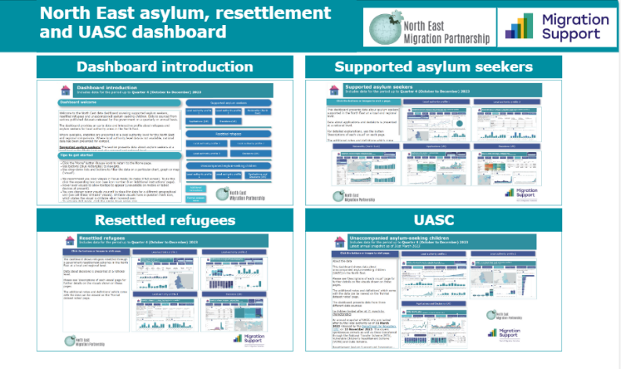
- Supported Asylum Seekers Dashboard: Data about asylum seekers supported in the North East at a local and regional level.
- Resettled Refugees Dashboard: Data about refugees resettled through government resettlement schemes in the North Eat at a local and regional level.
- Unaccompanied Asylum-Seeking Children Dashboard: Data about Unaccompanied Asylum Seeking Children (UASC) in the North East.

Asylum
Home Office statistics
To access the raw publicly available information, click here.

National Dispersal, Initial and Contingency Accommodation Data
At the end of Q1 2026, there were 92,664 asylum seekers in receipt of support in dispersed, Initial and Contingency Accommodation across the UK. The North East region currently houses 8% of asylum seekers in all accommodation types which has increased slightly due to the closure of hotels elsewhere in the country reducing overall figures in other regions; with Government announcements indicating at their height there were around 400 hotel sites and that this is down to under 190 in April 2026.

Please see the below table for a national breakdown.

Table 1: National totals for dispersal/initial and contingency accommodation – March 2026
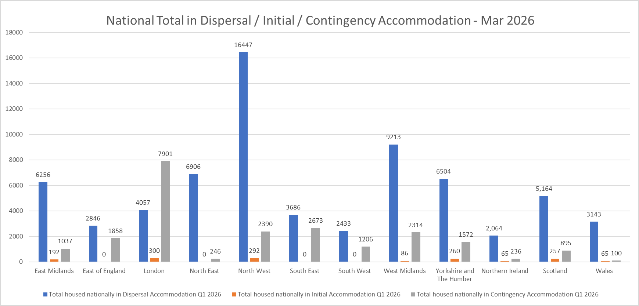

Regional Dispersal and Contingency Accommodation Data
At the end of Q1 2026, there were 7,152 asylum seekers in receipt of support in Dispersal and Contingency Accommodation across the North East region. This is a reduction of 253 asylum seekers in receipt of support from Q1 2025 (7,405 in support across Dispersal and Contingency Accommodation). County Durham has seen the largest increase across with it being the only local authority remaining in the region with a significant accommodation pipeline with it joining dispersal more latterly under the Governments full dispersal arrangements. County Durham has increased by 133 service users; Newcastle upon Tyne and Gateshead have seen the biggest decreases with a reduction of 249 and 106.

Table 2: North East total in Dispersal/Contingency Accommodation – March 2026

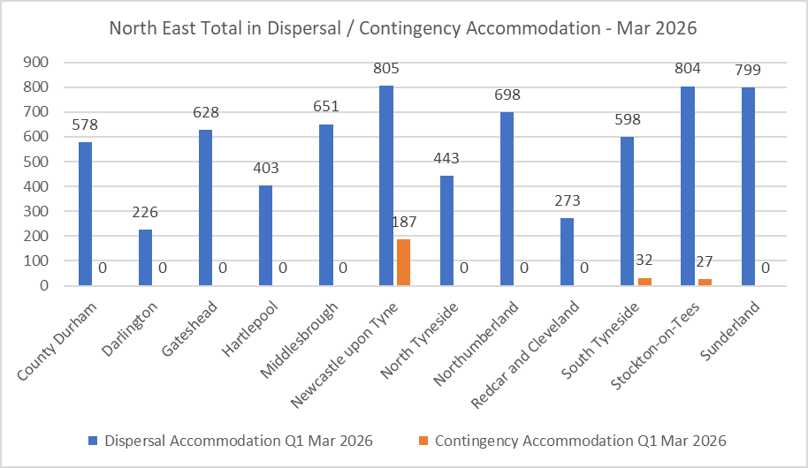

Evaluation of the initiatives to enhance the move on process
This report is a UK government evaluation of initiatives designed to improve the move-on process for people leaving asylum support and transitioning into longer-term housing. It assesses how effective recent policy changes and support measures have been in helping individuals avoid homelessness and access accommodation more smoothly. The evaluation draws on evidence from multiple sources to identify what has worked well, the challenges faced, and recommendations for improving the system. The report can be found here.

Immigration Advice Authority campaign
The Immigration Advice Authority (IAA) has launched its first national awareness campaign to protect people from fraudulent, unregulated immigration advisers. Please share this information with your service users.

Use of Artificial Intelligence Tools
On 17 April 2026, the Home Office confirmed that mandatory AI training was completed by all staff in 2025, with additional training provided to asylum caseworkers before rollout of the Asylum Policy Search (APS) tool. Both APS and the Asylum Case Summarisation (ACS) tool have undergone user acceptance testing and post‑pilot evaluation, with all usage logged and auditable and a feedback mechanism in place for decision‑makers. Ongoing expert testing continues for APS, while ACS has not yet been operationalised, with further evaluation planned before deployment. Further detail is set out in the Home Office’s published Evaluation of AI Trials in the Asylum Decision-Making Process, available here.

UK-France Agreement to Strengthen Action on Small Boat Crossings
On 23 April 2026, the UK and France agreed a new multi‑year partnership to strengthen joint action to reduce illegal small‑boat crossings in the Channel. The agreement increases UK support for enforcement operations in northern France and is underpinned by joint monitoring and evaluation arrangements. The deal includes a significant uplift in frontline law enforcement capacity, with deployments increasing by 42% to nearly 1,100 officers, front‑loaded ahead of the summer period. It also provides for enhanced surveillance and interception capability, including the expanded use of drones, helicopters, and camera systems, alongside strengthened maritime operations to disrupt departures and intercept small boats before or shortly after launch.

Migration Observatory: UK Asylum Backlog
A briefing published by the Oxford Migration Observatory on 22 April 2026 shows that while the UK’s initial asylum decision backlog has fallen sharply, pressures have shifted to the courts. The initial backlog dropped to 49,000 applications by the end of 2025, the lowest level since 2020, driven by a significant increase in Home Office decision-making. However, the asylum appeals backlog nearly doubled in 2025, reaching around 80,000 cases, reflecting higher refusal volumes and limited capacity in the tribunal system. Appeals were successful in 39% of cases, and delays continue to contribute to high system costs, with asylum spending reaching £4.8 billion in 2025 despite a year-on-year reduction. The briefing highlights caseworker productivity, appeals capacity, and accommodation pressures as key factors shaping progress on reducing overall backlogs.

Unaccompanied Asylum Seeking Children (UASC)
Department for Education children looked after data
The Department for Education released the yearly figures for children looked after (CLA) across England, which provides a national picture for the number of UAS children who are currently looked after by local authorities across the country.

Table 3: Total number of UASC looked after by local authorities between 2021 and 2025

As illustrated above, the number of UAS children looked after peaked in 2024 with 7,440 children in local authority care and has fallen by 12% in 2025 with 6,540 UAS children in care. In 2025, UAS children represent 8% of the total number of children looked after in England (up from 5% in 2021). The majority of these young people living in Ofsted-registered supported accommodation properties and 38% in foster placements. Most UASC are male (94%) and are also usually older - 90% were aged 16 years or older, compared to 27% of all CLA.

NTS Publicly Available Data
The graph below shows the number of unaccompanied asylum-seeking children who transferred into North East local authorities under the Governments mandated National Transfer Scheme (NTS) for Q1 2026, and a comparison of previous years for the North East. This publicly available data can be found here. The number arrivals in Q1 2026 compared to the last two years had decreased, which may be due to the impact of the weather on small boat arrivals as channel crossings are down by 33% compared to Q1 2025.

Table 4: North East NTS Transfers – Q1 Comparison

Nationally, 375 children transferred during Q1 2026 with North East local authorities receiving 6% of NTS transfers. Since the scheme began, between 1 July 2016 and 31 March 2026, 14,136 children have transferred via the NTS. Of those transfers, 12,376 children have been transferred to local authorities under the NTS Rota mechanism that was introduced in July 2021.

Age Assessment Data
The Home Office immigration statistics release reintroduces age assessment statistics published in the chapter ‘How many people have their age assessed?’. This includes new detail on the type and outcome of age assessments.

In the YE March 2026, 6,400 people were age assessed for the first time, 3% less than the previous year, and 43% of people who have received an outcome were found to be adults. Of those deemed to be adults at their first age assessment in July to December 2025, 17% were later found to be children. This percentage may change over time as further age assessments are completed.

Training: Child Trafficking & Exploitation (UK)
This CPD-certified online course helps professionals understand and respond to child trafficking, modern slavery, and exploitation in the UK. It is open to a wide range of practitioners. The cost is £60 per session (£120 total for module 1 and 2).

Module 1: Key concepts, forms of exploitation, children’s rights, and the National Referral Mechanism
Module 2: Safeguarding, disruption, and trauma-informed approaches

Dates: June or September 2026 (choose preferred sessions).
Contact: training@ecpat.org.uk

UASC News Articles
Immigration Officers more likely to assess UASCs as adults – The Guardian
Home Office data shows immigration officers are more than twice as likely as local authority social workers to assess young asylum seekers as adults, with border officials identifying only 32% as children compared with 68% by social workers. Critics warn that rushed visual assessments at the border are wrongly placing children in adult accommodation causing serious safeguarding risks.

Charities decry UK plan to use AI to assess age of young asylum seekers | The Guardian
A coalition of more than a hundred refugee children’s organisations has said controversial plans to use AI to assess the age of young asylum seekers could lead to more children wrongly ending up in adult prisons or detention centres.
The consortium, whose member organisations work to promote and protect the rights of refugee and migrant children, say that as a result of trauma, under-nutrition and the harrowing journeys the young people have undertaken to reach safety means AI assessment is complex.

Ukraine Schemes
Ukraine Permission Extension (UPE) Scheme – 90-day application window open
The UPE scheme has been extended for a further 24-months following the initial 18-month period, taking the total permission under UPE to three and a half years. Since 8 April, applicants have been able to apply for this extension 90-days before the current permission expires. Applying at any point within the 90-day window will not reduce the total permission granted as any remaining valid permission will be added to the new grant. It remains free to apply and to qualify, applicants must:
- currently hold permission under UPE;
- be physically present in the UK (or Islands) at the date of application;
- have been living in the UK (or Islands) since being granted permission under the Ukraine Schemes, including the UPE. Temporary periods spent outside the UK - defined as absences of no more than 12 months, whether continuous or cumulative - will not count as time outside the UK for the purposes of this requirement.

Valid passports are also required to apply for UPE. In December 2025 a new passport service for Ukrainian citizens was introduced in London and Glasgow, meaning applicants no longer need to travel back to Ukraine to obtain a passport for their UPE application. The Home Office has also advised that expired BRPs should be retained, as this may help prevent further delays in the application process.

Move to the UK from Ukraine: Guidance Updates
The government has updated its “Move to the UK if you’re coming from Ukraine” guidance with the following changes:
- 8 April 2026: The guidance was updated with information on applying to the Ukraine Permission Extension scheme and the use of permission to travel letters.
- 21 April 2026: A new Ukrainian-language translation of the guidance was published.

The guidance sets out what individuals need to do before travelling to the UK and after arrival, and is available on GOV.UK here.

Refugee Rent Deposit Scheme sponsored by Beam – New Website Launch
The Refugee Rental Deposit Matching Scheme has launched a new website, making it easier for partners and referrers to access information about the programme and submit referrals. The site includes clear eligibility guidance, details on how the scheme works, and direct referral links. Partners are encouraged to share the website widely within their networks to help reach more eligible households.

The scheme continues to support members into safe and stable accommodation:
- A Place to Call Home: A member and her young daughter, who arrived in the UK after fleeing the war in Ukraine, secured stable housing shortly after she began work. With deposit and first month’s rent support, and a guarantor in place, they were able to move quickly into their new home and begin rebuilding their lives with stability and confidence.

A new Ukrainian Education Hub to support displaced Ukrainians has opened in Leeds with the aim of providing advice on education, careers and culture and uniting British and Ukrainian people. It is the sixth Ukrainian Education Hub in the UK joining similar facilities in London, Chichester, Oxford, Bath and Manchester. They welcome people from across the North East.

Homes for Ukraine helped save thousands of people. But life for Ukrainian refugees is still uncertain: Big Issue
The Homes for Ukraine scheme provided vital safety to thousands of people fleeing the war, driven by an unprecedented public response and generosity from UK hosts. However, refugees continue to face uncertainty due to complex bureaucracy, restrictive Home Office policy changes, and an unclear long-term pathway to settlement. Despite these challenges, community-led support remains strong as the war enters its fifth year.

Hong Kong BN(O) Update

UK Immigration: ID Check App Now Available for BN(O) Settlement Applications

From today, applicants applying for settlement on the BN(O) route can prove their identity using the UK Immigration: ID Check app. This applies to applicants holding a BN(O) or Hong Kong SAR passport, allowing them to verify their identity digitally as part of the online settlement application process. Applicants using other types of passports will still need to attend a UKVCAS appointment to provide their biometrics in person. Applicants should continue to rely on the Immigration Rules and official GOV.UK guidance for the most up-to-date and authoritative information.

Read the Settlement on the British National (Overseas) (BNO) route: Frequently Asked Questions here.

How to help refugees into employment
English Unlocked have developed a two-hour workshop focusing on the UK job market and its specific barriers for Hong Kong BN(O)s and Ukrainians. These workshops have been designed for anyone who supports forced migrants to find employment and they will find the training useful. For ESOL teachers, employment advisors, and resettlement teams, the challenge isn’t just fixing up a CV; its helping clients unlearn the professional habits of their home countries and adapt to the specific expectations of the UK job market. For more information or to enquire about attending the workshop, visit: How to help refugees into employment - English Unlocked

STEP North East regional learning event
Since 2016, World Jewish Relief has delivered STEP (Specialist Training and Employment Programme), supporting refugees and forced migrants in the UK to access sustainable employment through personalised employment, language and training support. Last year, with funding from MHCLG and in partnership with the British Council, World Jewish Relief launched a new STEP programme supporting Ukrainians and Hong Kong BN(O) visa holders. Participants could choose between a three-month intensive or six-month flexible programme and more than 4,000 people enrolled.

To reflect upon the programme, World Jewish Relief and NEMP co-facilitated an online regional learning event focused on the North East on 4 June to explore the programmes successes, challenges and case studies from the region, including how smaller local programmes complimented larger-scale delivery. Local authorities, VCS and other key stakeholders working with Hong Kong BN(O)s and Ukrainians were invited to attend with an opportunity for active participation and bespoke North East feedback.

BN(O) news stories
A UK immigration officer has been found guilty of assisting a foreign intelligence service after tracking Hong Kong dissidents using his Home Office computer and sending information to Chinese authorities. Meanwhile two people have been arrested on immigration offences after a BBC undercover investigation on immigration advisers. (Source: BBC)

Refugee Resettlement
Change in Afghan Resettlement Programme (ARP) support

The Government is now enforcing the immigration rules that require eligible individuals to attend a Visa Application Centre appointment within 12 months (from 28 April 2026). In addition, a backstop of December 2028 has been introduced for MOD support in third countries. This means that, except in exceptional circumstances, December 2028 will see the final relocations to the UK under the ARP.

The statement also confirms a change in relocation policy, with government-supported assistance for travel out of Afghanistan to be withdrawn. Eligible individuals will instead be expected to make their own way to a third country to continue their visa application process, aligning the programme more closely with other resettlement routes. A timeline has also been set out for concluding the scheme, including as above the backstop of December 2028 for relocation support, alongside plans to reduce the use of hotels and defence accommodation as part of a transition toward longer-term housing through local authorities.

Ministerial Statement is available here - Written questions, answers and statements - UK Parliament
Gov.UK Policy Update is available here - Afghan Relocations and Assistance Policy

Gov.UK publishes the number of families coming to the UK through safe and legal routes. A summary of resettlement arrivals are as follows:

There were 4,894 people resettled in the year ending March 2026. This is 37% fewer than the previous period. Of those resettled in the year ending March 2026:

- 90% (4,409) arrived through the Afghan Resettlement Programme (ARP); the remaining 10% (485) arrived through the UK Resettlement Scheme and Mandate Scheme.
- The most common nationality was Afghan (90%), whereas prior to 2021 the most common resettled nationality was Syrian most of whom were resettled under the now closed Vulnerable Persons Resettlement Scheme (VPRS).

In July 2025, the Government confirmed that there will be no further ACRS pathways or referrals, ARAP is closed to new applicants and that ARR is discontinued. However, existing applications on these schemes will continue to be processed and therefore, there will be arrivals in future quarters. For further detail please see guidance on the Afghan Resettlement Programme. Since the first arrivals in 2021, the Afghan Resettlement Programme has resettled a total of 38,617 people.

Of the 38,617 people on the Afghan Resettlement Programme, 38% (14,842) were brought to the UK in July to September 2021, immediately following the Taliban takeover in Afghanistan in August 2021.

Table 5: Annual arrivals on the Afghan Resettlement Programme, by Scheme, up to March 2026
 | 2021 | 2022 | 2023 | 2024 | 2025 | 2026 (Q1 only) | Total
ACRS | 9,258 | 497 | 797 | 2,061 | 1,271 | 207 | 14,091
ARAP | 7,171 | 4,238 | 2,898 | 3,950 | 1,538 | 233 | 20,028
ARR | z | Z | z | 1,180 | 3,061 | 227 | 4,468
Total ARP arrivals | 16,445 | 4,737 | 3,695 | 7,199 | 5,874 | 667 | 38,617

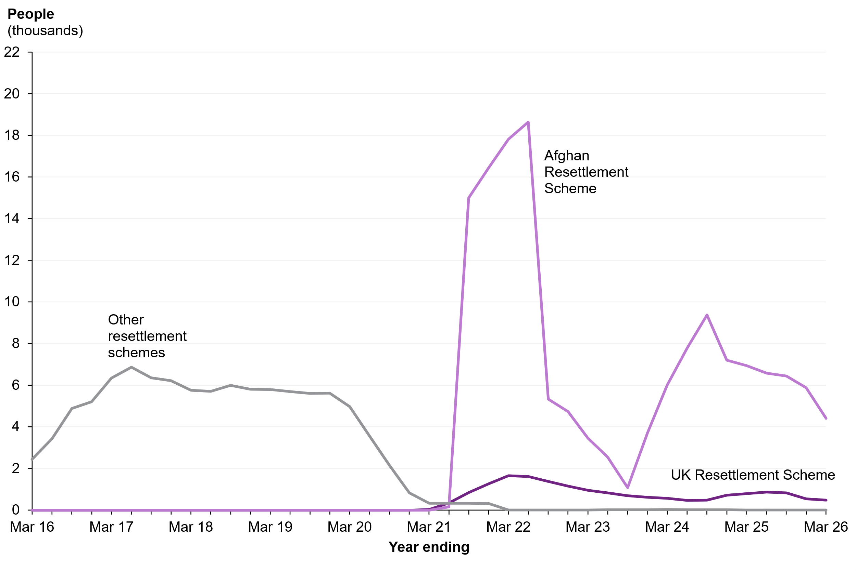
Table 6: People resettled and relocated, by scheme, year ending March 2016 to year ending March 2026
North East Details
In 2026/26 there has been 299 arrivals into the North East region, comparatively in 2024/25 there were 457 arrivals into the North East region. This demonstrates and reflects the slight dip in national arrivals in 2025/26. Detailed information on LA arrivals is detailed below and further information available here.

Local Authority | Arrivals in 2025/26
County Durham | 34
Darlington | 0
Gateshead | 47
Hartlepool | 8
Middlesbrough | 8
Newcastle upon Tyne | 58
North Tyneside | 0
Northumberland | 63
Redcar and Cleveland | 7
South Tyneside | 21
Stockton-on-Tees | 34
Sunderland | 19
Total | 299

UNHCR have published the Global Resettlement Needs document which looks at projected needs for refugee resettlement across the world. Available here to download - Projected global resettlement needs 2026 | UNHCR UK

The projected needs in the Middle East and North Africa (MENA) region and Türkiye have seen a substantial reduction, due to the situation in Syria. While return has become a viable option for many, nearly 443,000 Syrians still require resettlement, making them the second largest group in need. Conversely, resettlement needs for Afghans — now the largest refugee population in need of resettlement — along with South Sudanese, Sudanese, Rohingya and Congolese (DRC) refugees have all increased. The needs of Sudanese refugees, in particular, have risen by 30 per cent, driven by ongoing displacement into neighbouring countries in West and Central Africa, the Eastern Horn of Africa and the Great Lakes as well as the MENA region. In 2026, Iran is expected to have the largest resettlement needs, while notable increases are seen in Pakistan, Chad, Bangladesh and Uganda.

UNHCR found that there are 2, 527, 185 individuals in need of resettlement, this is across 77 host countries and families from 45 countries of origin. The below table shows the top host countries for refugees across the globe:
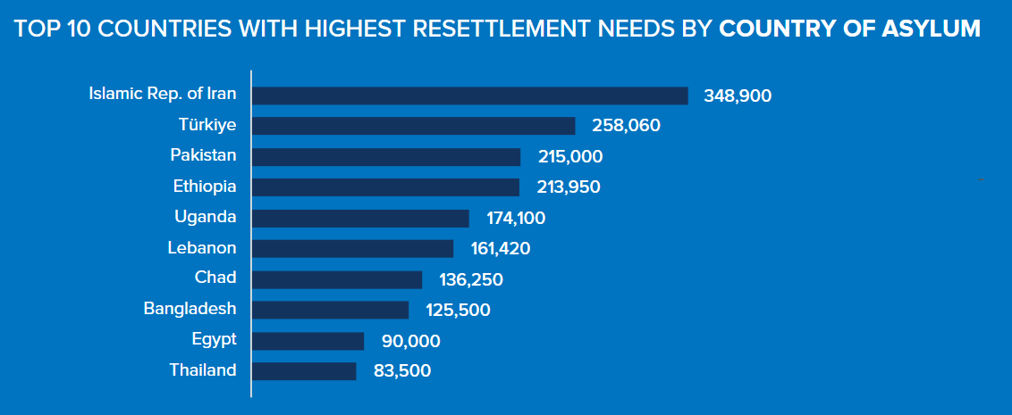

Communities for Afghans
New guidance for those considering looking at supporting Afghan refugees, in a similar way to how Homes for Ukraine has worked.

The Communities for Afghans scheme is part of the wider Afghan Resettlement Programme (ARP), which supports eligible Afghans arriving in the UK with Indefinite Leave to Remain. This guidance sets out how the sponsorship model works and clarifies the roles and responsibilities of all partners involved.
The scheme aims to provide safe and affordable housing quickly by enabling community groups to directly welcome and support Afghan households. It uses a community sponsorship model, meaning successful resettlement relies on strong collaboration between HM Government, Principal Sponsors, Sponsor Groups and local councils.

Under this model:
- Principal Sponsors recruit, train and support Sponsor Groups, oversee delivery, and act as a key point of contact for resolving issues.
- Sponsor Groups provide day-to-day support over three years, including sourcing accommodation and helping families settle and become independent.
- Councils manage government funding, deliver longer-term integration support, and maintain statutory responsibilities such as safeguarding and housing.

The guidance emphasises partnership working and flexibility, with funding designed to reflect shared responsibilities and enable councils and community partners to meet the needs of each household effectively. Further information on the guidance and information on the scheme is available online here.

ESOL & Employability
Scholarships for asylum seekers
The Schwab & Westheimer Trust has worked with other generous donors to create new and different scholarship opportunities. This year, the scholarships offered will include:
- The Westheimer Scholarship (for an undergraduate degree in social work, medicine, nursing, or related health or social care professions)
​- The Claus and Mary Moser Scholarship (for an undergraduate degree or equivalent professional qualification in engineering or accounting)
​- The Ralph N Emanuel Scholarship (for an undergraduate degree with a clear humanitarian purpose)
You can use the Displaced Student Opportunities Portal and STAR's website to find out what other opportunities are available for 2026 and 2027.

NATECLA Annual Conference
The NATECLA annual conference will take place on 26–27 June 2026 at Conference Aston, Birmingham.
The annual NATECLA conference is the leading event in the ESOL teaching calendar and has been for over 25 years. It is an opportunity to join ESOL and ELT practitioners from all over the UK and Ireland to engage in talks and workshops, discussion and ideas-sharing sessions, a diverse exhibition area and relaxed social activities

The conference will include and opportunity to network with likewise professionals and is offering over 40 workshops, including:
- From Language to Livelihoods: Embedding Employability in ESOL
- Sketchnoting Sparkle: Super-Charging Notes, Whiteboards and More with Simple Doodles
- Feedback That Listens: Shaping Learning Through Noticing
- Crafting a Standout Beacon Award for Excellence in ESOL Submission
- A Phonics-Led Approach to Literacies Teaching
- Low-Prep, High-Impact: Ideas for a Creative Teacher's Toolkit
For further information you can get in touch by emailing info@natecla.org.uk. You can register for tickets using the link here.

Healing Classrooms free training
The Healing Classrooms programme aims to support schools and educators to develop inclusive and nurturing learning spaces where refugee and asylum-seeking students can gain the necessary academic, social and emotional skills to develop their full potential. International rescue committee offer free training sessions and resources to educators and schools supporting refugee and asylum-seeking students in the UK. For further information, you can find the website linked here.

NEMP Working Groups
NEMP organises and attends ESOL working groups as a collaborative forum that brings together key partners in a locality who support migrant, refugee, and multilingual communities. The aim is to: -
- Improve access, coordination, quality, and progression pathways in ESOL provision.
- Map existing ESOL provision and identify gaps.
- Strengthen partnerships between providers, community groups, and employers.
- Improve learner pathways (e.g., from pre-entry to accredited courses or into employment).
- Coordinate referrals to avoid duplication and ensure people don’t fall through gaps.
- Share resources, best practice, and training across organisations.
- Respond collectively to local needs, policy changes, and funding opportunities.
- Promote consistent standards and inclusive approaches across the area.

The groups are attended by partners from: -
- ESOL course providers (colleges, training organisations)
- Local authority teams (e.g., education, communities, adult learning)
- Refugee/asylum seeker support organisations
- Migrant community groups
- Jobcentre Plus / employment support partners
- Employers interested in inclusive recruitment
- Volunteer ESOL providers

The ESOL working groups exist to bring together organisations that support migrants, refugees, and multilingual communities so they can work collaboratively to improve local ESOL provision. The purpose is to create a coordinated, high quality ESOL ecosystem where learners can easily access the right support, progress through clear pathways, and avoid falling through gaps in provision. NEMP is currently arranging working groups for Stockton and Middlesbrough and will progress through the region.

Refugee Employability
As we move forward into a year with no planned Home Office commissioned Refugee Employability programme. NEMP will look to support local and national employers to improve inclusive hiring and build confidence in refugee recruitment. NEMP will support employers to have the knowledge, tools, and confidence needed to recruit fairly and benefit from displaced talent. NEMP will deliver employer workshops and masterclasses, partnering with DWP, local authorities, and employer networks, alongside offering one-to-one employer support, including job carving, role redesign, and support with advertising vacancies in accessible ways. If any organisations are interested in partnership work, contact nemp@middlesbrough.gov.uk

ESOL Research Community
The next ESOL Research Community event Evidence-based approaches to teaching ESOL literacy learners will be held on Thursday 11th June, online, from 4-5.30pm GMT.

Judy Kirsh will share key findings from literacy and second language acquisition research, alongside current theories of how adult ESOL learners acquire reading and writing skills. The session will connect research evidence to classroom practice, highlighting evidence-based approaches and recommended strategies shown to support progress for ESOL literacy learners. To register for the event, please complete this Form - ESOL Research Community 11th June Event

Salvation Army Resource
A conversation café is an informal, welcoming space where people can practise everyday English, build confidence and connect with others. This free ESOL resource, created by The Salvation Army in partnership with 2:19 Teach to Reach, helps café leaders explore modern slavery in a safe, practical and accessible way. It uses story, discussion, picture cards, vocabulary activities and role play to help learners recognise exploitation, practise asking for help and understand where support is available. The resource is especially relevant for groups welcoming refugees, people seeking asylum, migrants and others who are new to the UK or Ireland. People who are isolated, unsure of their rights, or still learning English can be more vulnerable to being targeted and exploited.

Specialist Language Courses – Driving Theory Test
SLC are delivering a driving theory test preparation programme for ESOL learners. The course runs twice a week over two months including 17 sessions of 1.5 hours each and brings together several approaches and high degrees of personalisation:

- Tutored Zoom lessons – starting with language input before moving into guided practice
- Shared whiteboard activities in class, analysing and discussing:
  - Learner photos of road signs and junctions (uploaded prior to the lesson on the course management app)
  - Google Maps Street View references (also uploaded by learners)
  - AI-generated images of road configurations, often created in real time in response to learner questions
- Integration of the government's Safe Driving for Life digital course – both within and between sessions

For further information, please see the flyer below.

NEMP Website
Please access the NEMP website by clicking here. NEMP continues to update the various hubs with information, updates and resources, such as our Welcome to the UK guides, guidance and advice, which we hope you will use to help new arrivals with information they need to help them settle in the UK. The website also includes our local service directory, which is in the process of being updated for all local organisations and the services they offer.

Please also make use of the Welcome Resources too with groups or individuals you are supporting. There are different ways you can use them to engage such as; you can download leaflets, help them access and complete the E-learning modules and print off their certificate when they finish, watch the videos in their own language or you can organise interpreters and deliver the presentations with full scripts in a group session like Refugee Futures do in Stockton-on-Tees. If you would like to discuss further, please get in touch with NEMP!

If you have any suggestions for the NEMP website or would like to update a service on the directory, please get in touch by emailing nemp@middlesbrough.gov.uk.

Health
TB educational videos translated into local languages have been developed in partnership between Touchstone, Leeds City Council and the Leeds Community Healthcare TB service. The short videos cover key messages on TB signs and symptoms, testing and treatment and signposting to services and resources for further information.

Delivery of Holistic and Inclusive Care to People Seeking Asylum and Refugees
The London based Respond integrated refugee health service has developed this short course to support staff working with people seeking asylum and refugees. It’s co-developed with people with lived experience, and it provides helpful tips about how to support this group to access healthcare effectively. It is accessible via the NHS Learning Hub here.

Study exploring the experiences of healthcare staff working with refugees and asylum seekers
European Society for Traumatic Stress Studies (ESTSS) with King's College are recruiting participants for a study looking at experiences of healthcare staff working with refugees and asylum seekers across Europe. Participants can be any healthcare professional who have worked with someone from this population in the last 12 months. It's a qualitative study so would involve being interviewed by the research team. More details here.

New free Intercultural Awareness Guide and CPD-accredited online training course
A new Intercultural Awareness Toolkit and free CPD-accredited online course is now available for the 0–19 workforce, designed for midwives, health visitors and school nurses – and anyone working with children and young people seeking asylum and refugees. These resources support culturally sensitive, trauma-informed care for children, young people and families seeking asylum or with refugee status. They build on the success of recent in-person training across the South East, where practitioners reported greater confidence, improved communication and a stronger ability to support families facing challenging circumstances. Both the toolkit and online course are free to access and can be used individually or within teams.

British Red Cross research report – elective care access while seeking asylum
This new report highlights the specific challenges refugees and people seeking asylum face while waiting for and accessing elective care, and the consequences this can have for their health. The research draws on interviews with seven people seeking asylum in England and three professional experts and found that:
- Long waits for elective care often have a significant mental health impact, made worse by a lack of information and uncertainty about both healthcare and asylum processes.
- Communication barriers, including missed letters and language challenges, as well as practical barriers, such as transport costs and lack of childcare, can increase the risk of people missing appointments.
- Relocation frequently disrupts continuity of care, with no clear system to ensure people remain on waiting lists or are safely transferred.
- Many people rely on ‘pockets of excellence’ or individual advocacy, leaving those without support at risk of falling through the gaps.

The report sets out recommendations for the Department of Health and Social Care, NHS England, commissioners, providers and the Home Office. These include improving communication about elective care, better access to schemes supporting with transport costs, and avoiding or mitigating for relocation of people accessing elective care.

Modern Slavery
Anticipating Exploitation: A Futures Analysis
This report, “Anticipating Exploitation: A Futures Analysis,” was published by the UK’s Independent Anti‑Slavery Commissioner and examines how patterns of modern slavery and exploitation may evolve in the future. It explores emerging risks, trends and scenarios to help policymakers and organisations better prevent and respond to exploitation. Access the report here.

National Referral Mechanism (NRM) and Duty to Notify (DtN) statistics - Q1 2026 - January to March Published 14th May 2026
This statistical bulletin provides a summary and breakdown of the number of potential victims of modern slavery referred into the NRM or via the DtN between 1 January and 31 March 2026. Please refer to the data tables published alongside this bulletin for additional data.

Key results
- A total of 6,003 potential victims of modern slavery were referred to the Home Office from January to March 2026, a figure like the previous quarter (6,017) but a 13% increase compared to the period January to March 2025 (5,294)
- 74% (4,451) were sent to the Single Competent Authority (SCA) for consideration and 26% (1,552) to the Immigration Enforcement Competent Authority (IECA)
- Potential victims from the UK (24%; 1,435), Eritrea (11%; 654) and Somalia (8%; 503) were the most frequently referred nationalities
- Referrals for UK nationals from January to March were the highest in a single quarter since the NRM began
- January to March 2026 saw the highest total number of referrals reporting exploitation exclusively in the UK in a single quarter since the NRM began (2,448)
- A total of 5,990 reasonable grounds and 5,680 conclusive grounds decisions were issued between January and March 2026; of these, 65% (3,876) of reasonable grounds and 68% (3,846) of conclusive grounds decisions were positive
- There were 4,726 cases awaiting a decision at the end of March 2026, a decrease of 18% from the end of December 2025 (5,758) and of 84% from the peak recorded at the end of 2022 (29,275)
- The average (median) age of cases awaiting a conclusive grounds decision at the end of March 2026 was 53 days, compared to 76 days at the end of December 2025 and 678 days at the peak in June 2024
- The Home Office received 1,628 reports of adult potential victims via the DtN process between January and March 2026, representing a reduction of 7% compared to the previous quarter (1,748), but an increase of 1% compared to the same period in 2025 (1,609)

Data briefing explores geographic and demographic patterns of exploitation in the UK by Modern Slavery and Human Rights Policy and Evidence Centre led by University of Oxford.

No Recourse to Public Funds (NRPF)
Proposed Settlement Changes Could Increase Child Poverty
New independent analysis warns that proposed Home Office changes to the route to settlement could leave up to 90,000 children of migrant workers in poverty by 2029.
The research, commissioned by the No Recourse to Public Funds (NRPF) Partnership, examined plans to extend the pathway to settlement from five to 10 years or more. It found that delaying access to settlement—and therefore to public funds—would prolong financial hardship for many working families already living in the UK.
If the changes go ahead, around half of children in families on work visas could be living in poverty by 2029. In contrast, keeping the current five-year route could significantly reduce child poverty levels.
The findings highlight impacts on key worker families, including those in health and care roles, and raise concerns about alignment with the Government’s Child Poverty Strategy.
Organisations behind the research are calling for the proposals to be reconsidered, warning that extending settlement timelines risks undermining opportunities for children to thrive.
NRPF Network Support for Local Authorities
Councils, the NHSE, Health and Social Care trusts, and other organisations can contact the NRPF network for free advice by email at: nrpf@islington.gov.uk. If the query relates to a person you are assisting, please provide a summary of the relevant circumstances, omitting any personal identifying information. NRPF aim to respond to all enquiries within 5 working days.

Migrant Help Update
Please see Migrant Help’s most recent newsletter here which includes updates on safeguarding, outreach, move on and more as well as alternative ways to contact them if you are experiencing long wait times when calling their generic telephone number. The main ways to contact are the webchat, raise an issue via their website or the freephone.
- Webchat
- Raise an Issue via our website
- Freephone helpline - 0808 8010503

Funding Opportunities
NEMP also provide and circulate a regular round-up of known funding opportunities, please see the most recent one attached below for a full list of current grants. Please email nemp@middlesbrough.gov.uk if you would like to be added to the circulation list or note something we have missed.

Refugee Week 2026

Sir Quentin Blake has illustrated this year’s Simple Acts for Refugee Week 2026, bringing his distinctive warmth and humanity to the campaign. The 2026 Simple Acts illustrations are free for communities to use in classrooms, libraries, community spaces, online platforms, and events.

Free posters and postcards are available to order from the Refugee Week Shop, alongside a free Social Media Toolkit to support Refugee Week promotion and publicity.

Refugee Week 2026 – film festival: Programme and Resources
The Refugee Week Film Festival 2026 programme has been announced, featuring two feature films and five short films exploring themes of displacement and community. Resources are available to support free community screenings, with preview access from 10 May and film links shared ahead of the festival for organisers. Access to FAQs, discussion prompts, promotional materials and social media toolkit can be found here.

© Quentin Blake

City of Sanctuary – Poetry Readings
To kick off Refugee Week 2026, on 16th June 7:00-8:00pm, the City of Sanctuary are hosting an online evening of poetry readings from poets published by The Other Side of Hope.

Newcastle Refugee Week Event Calendar - June 2026
The theme for this year’s refugee week is ‘Courage’. A non-exhaustive list of events being hosted by organisations in Newcastle and surrounding districts can be found here, everyone is welcome to attend.

News and Reports
Regional Refugee Forum North East – Job Vacancy
The Regional Refugee Forum North East is recruiting for a part-time Communication Officer to support the development and growth of communication activities in support of the Regional Refugee Forum North East and Refugee-Led Community Organisations (RCOs) across the Northeast of England. The application deadline is 3 July at 5:00pm and further details can be found here.

Common Ground Award 2025/26: Successful Applicants
The Government has published the list of successful organisations funded under the Common Ground Award 2025/26, a capital grant scheme supporting voluntary, community and social enterprise (VCSE) organisations that bring people together from different backgrounds and strengthen community cohesion. A total of 211 organisations across England have been awarded funding to support improvements to community spaces, facilities and equipment.

In the North East, 15 organisations were successful under the Common Ground Award 2025/26:
Blaydon Youth and Community Centre CIO | BME Network CIC | Cathedral Church of St Nicholas in Newcastle
Edberts House Limited | Feeding Families | Footprints in the Community
Grace House North East | Handcrafted Projects | Lifeline Community Action
Out North East | Scotswood Natural Community Garden Limited | The Customs House Trust Ltd
Triangular CIO | What’s Behind The Smile | YMCA Northumberland

Scotswood Gardens: Free Forest School Training
A Level 1 Forest School free training opportunity is available as part of their Cultivating Solidarity project at Scotswood Natural Community Garden. This training is for refugees and asylum seekers who are interested in working with children and nature with no previous experience required. The training will be delivered on the 2nd, 3rd, 16th and 17th July 2026 and in addition to the four days of certified Level 1 Forest School training, provides hands-on outdoor learning, team-building activities, nature observation sessions. After completing the training, participants may have the opportunity to attend project meetings, support planning and delivery of Forest School sessions and receive payment for their time if eligible to work in the UK. If you have any further questions, please contact umara@sncg.org.uk.

UK Trauma Council – Toolkits for children seeking sanctuary
The UK Trauma Council have a range of resources available which have been developed for adults supporting
children and young people seeking asylum in the UK, including those working in education settings, community
organisations and supported accommodation. The resources are free and available to download.

Crisis Comms Toolkit – IMIX and City of Sanctuary
IMIX and City of Sanctuary have produced a Crisis Comms Toolkit for refugee organisations to use to keep themselves safe and it offers advice on how to respond to the media in the event of negative comments. At the launch of the toolkit, they advised each organisation to have a designated person to handle any negative social media issues, this person should be familiar with the toolkit and if and how to respond with the support of their organisation.

Migrants in the UK labour market – Migration Observatory
A new briefing on migrants in the UK labour market, features new data demonstrating that the share of employee jobs held by non-UK citizens rose to 20% at the end of 2025, up from 15% in December 2020 and non-UK-born men were more likely to be employed than UK-born men in 2025. The Migration Observatory also analysed the data by sector, finding that health and care, administrative services, retail and hospitality were the most reliant on foreign labour.

After the fall: Why hasn’t falling immigration changed public attitudes?
British Futures have published a report in May 2026 investigating a major gap in public opinion between reality and perception. Although UK net migration has fallen sharply since 2023, most of the public are unaware and still believe immigration is rising.

Social Cohesion in 2026 – ‘More in Common’
A More in Common report on social cohesion in 2026 highlights a growing sense of division linked to migration in public attitudes. Nearly half of Britons (47%) now identify the divide between migrants and those born in the UK as one of the country’s most significant social divides, overtaking concern about inequality between rich and poor. The findings reflect the increasing salience of migration in national debate and differing views on whether social differences are seen as manageable or becoming more entrenched.

New Evidence Paper on Building Local Social Cohesion - Protection Approaches
Protection Approaches has published a new evidence paper setting out practical lessons for strengthening social cohesion at a local level, drawing on its work with Stoke-on-Trent to develop the city’s Community Cohesion Strategy. While grounded in local experience, the report is intended for wider use by local authorities and community partners, offering a structured approach and ten priorities for action to help understand drivers of division and embed cohesion into everyday governance and service delivery.

Big Leaf Filming/harassment advice
Big Leaf have produced an advice flyer in Amharic, Arabic, Dari, English, Pashto, Somali, Sorani, Tigrinya & Vietnamese to support young migrants who are concerned about their details being posted online by others in an attempt to intimidate them.

City of Sanctuary - Exploring migrant and climate justice through art and culture
The City of Sanctuary are holding an online session on the 17th June from 12:00-13:30pm to explore the intersection of climate and migrant justice through art and culture. They will platform examples of intersectional justice in practice, hearing from cultural organisations, creating spaces of welcome, support and opportunity for forcibly displaced people.

Local Government Association (LGA) Mis/Disinformation guidance
The LGA has recently published a guide for councillors setting out practical actions to help address disinformation, alongside a similar guide for officers available via the LGA Comms Hub.

Chartered Institute of Housing: May Newsletter
The latest Chartered Institute of Housing May newsletter from the housing rights website is available here. This edition has articles on:
- What Reform’s gains mean for housing and migration
- How the Refugee and Migrant Centre tackles housing issues
- How refugee homelessness spikes as Home Office policy changes
- And the usual round up of news items.

In addition, there is the previously circulated briefing by the Asylum Support Appeals Project, on reforming asylum support —effects of the government’s planned changes.

Learn About Britain resources
Learn About Britain (LAB) is a national charity working to educate those new to the UK, as well as young people growing up in Britain, about British history, citizenship and culture. LAB is looking to partner with local organisations to run free educational tours for newly arrived communities, as well as to piloting free online tutoring for people preparing for the Life in the UK citizenship test. Learn more about the project here.

New initiative to support local areas to reimagine and revive their struggling high streets
On 21 March, MHCLG announced £319 million of government funding to help communities to restore pride and opportunity in neighbourhoods.
The investment is delivered through four strands:
- High streets reinvigorated – £301 million High Streets Innovation Partnerships programme to help support local communities to revive high streets
- Safe places for children to play – £18 million of government funding to buy new and improve playgrounds
- Local progress accelerated – Plans are also moving forward for areas in the first phase of Pride in Place, providing communities with up to £20 million over 10 years
- Tearing up the rulebook on public spending – Five projects will test a new initiative to get local agencies such as councils, the NHS and schools to pool their cash and work together instead of operating in silos

There are 66 communities receiving playground funding, with the following North East local authorities benefitting from the funds are: Redcar and Cleveland, South Tyneside, Stockton-on-Tees, Middlesbrough, Sunderland, North Tyneside, Hartlepool, County Durham, Darlington and Northumberland.

Immigration Advice Authority Publishes April 2026 Stakeholder Newsletter
The Immigration Advice Authority (IAA) published its April 2026 edition of its stakeholder newsletter, bringing together the latest updates on its regulatory work, sector developments and upcoming activity. This edition includes:
- details of the IAA’s first national awareness campaign aimed at immigration advice seekers
- an update on changes to the EUSS registration category
- information on new IAA guidance coming soon, bringing existing guidance together into a single, clearer and more accessible resource
- a staffing update and further insight into the IAA’s ongoing work
- whether you work closely with immigration advice seekers or have an interest in the immigration sector, the IAA’s newsletters provide insights, important updates and opportunities to stay informed and engaged with its work.

Individuals can subscribe to receive future editions directly to their inbox by signing up to the IAA’s mailing list, here.

Positive migration stories:
Scheme to help Teesside refugees seek support - BBC News
Safe Steps aims to help vulnerable people wanting to make Teesside their home understand their rights and know how to report concerns, such as discrimination, as well as being able to access the support available to them. The two-year initiative has received £14,868 from the Cleveland Police and Crime Commissioner's (PCC) Protect and Support Fund.

Afghan Women United, a refugee-based team formed after the Taliban banned women’s football, has been approved to represent Afghanistan in official competitions by FIFA. This follows years of campaigning by players seeking recognition, funding and the right to compete internationally.

Born in Somalia during the civil war, Elias fled persecution and sought asylum in the UK, where volunteering and education helped him rebuild his life and find a sense of belonging. Now a British citizen, he runs two companies creating pathways to employment, integration and inclusion for refugees and asylum seekers. (Source: UNHCR).

Malick Thiaw and Yoane Wissa join refugee footballers a... | NUFC. Newcastle United players Yoane Wissa and Malick Thiaw recently spent an inspiring afternoon at NUCASTLE, joining people from over a dozen nationalities for small-sided games as part of the Foundation’s weekly refugee football sessions. The sessions use the power of football to promote wellbeing, build confidence and help people who have fled conflict feel part of their local community. Participants also benefit from wider support, including English language opportunities and access to partner services.

Darlington quiz night raises £2,000 for refugees | The Northern Echo
A sold-out quiz night in Darlington has raised around £2,000 to support people seeking sanctuary in the town. Organised by Darlington Assistance for Refugees (DAR), the event brought together volunteers, supporters and community members for an evening of fun and friendly competition at St Augustine’s Parish Hall. Funds were raised through ticket sales, a raffle, and homemade cakes and crafts created by DAR’s sewing group. The money will help DAR continue its vital work supporting people to settle, feel safe and rebuild their lives.

Mariupol Ukrainian refugee: Getting to East Cleveland | Darlington and Stockton Times
A Ukrainian refugee who fled the devastating conflict in Mariupol has rebuilt her life in Redcar and Cleveland, thanks to the Homes for Ukraine scheme and the support of the local community. Oksana Halchenko arrived in the UK in October 2022 after a perilous journey that began when she escaped war-torn Mariupol on crutches, without documents, and facing an uncertain future. Once a cultural leader in her home city, she described feeling “homeless” and unsure if she could start again.

Great British Welcome | UNHCR UK
UNHCR's 'A Great British Welcome' showcases inspiring stories from across the UK, highlighting how communities and refugees thrive together through everyday activities and shared experiences. From community cafés in Walthamstow and creative projects in Manchester, to cooking in Wales and climbing in Liverpool, the initiative celebrates how connection can be built through food, arts, sport, and social gatherings. Refugees are not only finding friendship and belonging, but also pursuing careers, contributing skills, and giving back to their local areas.

If you have received this newsletter via a colleague and would like to receive it directly, or if you would like to unsubscribe, or have any comments or suggestions for future content, please contact nemp@middlesbrough.gov.uk.

